**MINISTRY OF EDUCATION AND TRAINING**

**FPT UNIVERSITY**

**DOCUMENT REPORT**

Capstone Project Document

**VN Habit Tracker**

|  |  |
| --- | --- |
| **Group 3** | |
| **Group members** | Lưu Thành Đạt - SE61124  Nguyễn Quang Tuyến - SE62069  Nguyễn Hữu Thắng - SE62447  Phạm Thanh Tùng - SE61628 |
| **Supervisor** | Lại Đức Hùng |
| **Ext. Supervisor** | N/A |
| **Capstone Project code** | VHT |

- Ho Chi Minh city, September 14th 2018

Contents

**List of tables** 6

**List of Figure** 9

Definitions, Acronyms, and Abbreviations 10

A. Introduction 11

1. Project Information 11

2. Introduction 11

3. Current Situation 11

4. Problem Definition 11

5. Functional Requirements 11

6. Proposed Solution 12

6.1. Feature functions 12

6.2. Advantages and disadvantages 13

7. Role and Responsibility 13

B. Software Project Management Plan 14

1. Problem Definition 14

1.1. Name of this Capstone Project 14

1.2. Problem Abstract 14

1.3. Project Overview 14

2. Project organization 17

2.1. Software process model 17

2.2. Roles and responsibilities 18

2.3. Tools and Techniques 19

3. Project Management Plan 20

3.1. Software development life cycle 20

3.2. Phase Detail 20

3.3. All Meeting Minutes 23

4. Coding Convention 23

C. Software Requirement Specification 25

1. User Requirement Specification 25

1.1. Guest Requirement 25

1.2. User Requirement 25

1.3. Admin Requirement 26

2. System Requirement Specification 26

2.1. External Interface Requirement 26

2.2. System Overview Use Case 28

2.3. List of Use Case 29

3. Software System Attribute 90

3.1. Usability 90

3.2. Reliability 90

3.3. Availability 90

3.4. Security 90

3.5. Maintainability 90

3.6. Portability 91

3.7. Performance 91

4. Conceptual Diagram 91

D. Software Design Description 92

1. Design Overview 92

2. System architecture design 93

2.1. Web application architecture description 93

2.2. Mobile application architecture description 94

3. Component Diagram 96

4. Detailed Description 98

4.1. Class diagram 98

4.2. Class Diagram Explanation 99

4.3. Interaction Diagram 101

4.4. Activity diagram 104

5. User Interface Design 105

5.1. Mobile application user interface 105

6. Database Design 108

6.1. Entity relationship diagram (ERD) 108

6.2. Entity dictionary 108

7. Algorithms 111

7.1. Recommend the best habits for users by linear programming algorithm 111

E. System Implementation & Test 115

1. Introduction 115

1.1. Overview 115

1.2. Test approach 115

2. Database Relationship Diagram 116

2.1. Physical diagram 116

2.2. Data dictionary 116

3. Test plan 119

3.1. Features to be tested 119

3.2. Features not to be tested 119

4. System Testing Test Case 119

4.1. Test case 119

4.2. テストケース 131

F. Software User’s Manual 148

1. Installation Guide 148

1.1. Hardware Requirement 148

1.2. Software Requirement 148

2. User Guide 150

2.1. Login 150

2.2. Register 151

2.3. View Main Page 153

2.4. Add Habit 154

2.5. Edit Habit 157

2.6. Delete Habit 161

2.7. View All Statistic of User 164

2.8. Add Reminder 166

2.9. Delete Reminder 168

2.10. Add Group 169

F1. ソフトウェアユーザーマニュアル 172

1.インストレーションガイド 172

1.1. ハードウェア要件 172

1.2. ソフトウェア要件 172

2. ユーザーガイド 173

2.1. ログイン 173

2.2. レジスター 174

2.3. メインメニューを表示 176

2.4. 習慣を追加する 177

2.5. 習慣を編集する 181

2.6. 習慣を削除する 186

2.7. ユーザーの全統計を表示 188

2.8. リマインダを追加する 190

2.9. リマインダを削除する 192

2.10. グループを追加 193

G. Appendix 196

1. Sofware Engineering 9th Edition, By Ian Sommerville 196

2. StarUML Documentation For Activity Diagram 196

3. StarUML Documentation of IBM 196

4. UML For Drawing Diagram (2.0 Standard) 196

5. Android Studio Documentation 196

# **List of tables**

Table 1: Roles and Responsibilities 13

Table 2 : Hardware Requirement for Server 15

Table 3 : Hardware Requirement for Mobile 15

Table 4 : Software requirements 16

Table 5 : Roles and responsibilities 18

Table 6: Tools List 18

Table 7: Technique List 18

Table 8: Software Development Life Cycle Detail 19

Table 9: Phase 1: Infrastructure 20

Table 10: Phase 3: Web service 21

Table 11: Phase 4: Mobile app 22

Table 12 - <Guest> Login 30

Table 13 - <Guest> Register 33

Table 14 - <User> Sort Habit 35

Table 15 - <User> Feedback and Contact Us 37

Table 16 - <User> Set Reminder 39

Table 17 - <User> Edit Reminder 42

Table 18 - <User> Delete reminder 43

Table 19 - <User> Export Statistic File 46

Table 20 - <User> Add Habit 48

Table 21 - <User> Delete Habit 51

Table 22 - <User> Edit Habit 53

Table 23 - <User> Set Reminder Habit 56

Table 24 - <User> View Statistic Habit 58

Table 25 - <User> Add Journal 60

Table 26 - <User> Edit Journal 62

Table 27 - <User> Delete Journal 64

Table 28 - <User> Add Group 66

Table 29 - <User> Delete Group 68

Table 30 - <User> Edit Group 70

Table 31 - <User> Edit Profile 73

Table 32 - <User> Suggest Habit 75

Table 33 - <User> Filter Habit 77

Table 34 - <User> View Statistics 79

Table 35 - <User> View Top Habits 80

Table 36 - <User> Logout 82

Table 37 - <Admin> Reset Password 85

Table 38 - <Admin> View Feedback 87

Table 39 - <Admin> Reply Feedback 90

Table 40 - <Admin> View Statistics 92

Table 41 - Conceptual Diagram Dictionary 94

Table 42 - Component Web Dictionary 98

Table 43 - Component Android Application Dictionary 99

Table 44 - Class Diagram Dictionary 101

Table 45 - App User 101

Table 46 - User 102

Table 47 - Admin 102

Table 48 - Habit 103

Table 49 - Feedback 103

Table 50 – Reminder 103

Table 51 - Tracking 104

Table 52 - physical diagram dictionary 124

# **List of Figure**

Figure 1 : Waterfall model 17

Figure 2- System Overview Use Case 27

Figure 3- <Guest>Overview Use Case 28

Figure 4 - <Guest> Login 28

Figure 5 - <Guest> Register 31

Figure 6 - <User> Sort Habit 33

Figure 7 - <User> Feedback and Contact Us 35

Figure 8 - <User> Set Reminder 37

Figure 9 - <User> Edit Reminder 39

Figure 10 - <User> Delete Reminder 41

Figure 11 - <User> Export Statistic File 43

Figure 12 - <User> Add Habit 45

Figure 13 - <User> Delete Habit 48

Figure 14 - <User> Edit Habit 50

Figure 15 - <User> Set Reminder Habit 53

Figure 16 - <User> View Statistic Habit 55

Figure 17 - <User> Add Journal 57

Figure 18 - <User> Edit Journal 59

Figure 19 - <User> Delete Journal 61

Figure 20 - <User> Add Group 63

Figure 21 - <User> Delete Group 65

Figure 22 - <User> Edit Group 67

Figure 23 - <User> Edit Profile 70

Figure 24 - <User> Suggest Habit 72

Figure 25 - <User> Filter Habit 74

Figure 26 - <User> View Statistics 76

Figure 27 - <User> View Top Habits 78

Figure 28 - <User> Logout 79

Figure 29 - <Admin> Overview Use Case 81

Figure 30 - <Admin> Reset Password 82

Figure 31 - <Admin> View Feedback 84

Figure 32 - <Admin> Reply Feedback 86

Figure 33 - <Admin> View Statistics 88

Figure 34 - Conceptual Diagram 92

Figure 35 - Web application architecture description 94

Figure 36 - Mobile application architecture description 95

Figure 37 - Component Web Diagram 97

Figure 38 - Component Android Application Diagram 98

Figure 39 - Class Diagram 99

Figure 40 - Sequence Diagram for add new habit <User> 103

Figure 41 -Sequence Diagram for edit habit <User> 104

Figure 42 - Sequence Diagram for delete habit <User> 104

Figure 43 - Activity Diagram for habit 105

# Definitions, Acronyms, and Abbreviations

|  |  |
| --- | --- |
| **Name** | **Definition** |
| VHT | VN Habit Tracker |
|  |  |

1. Introduction
2. Project Information

* Project name: **VN Habit Tracker**
* Abbreviation: **VHT**
* Product Type: **Web app & Mobile app**
* Start Date: **September 10th 2018**

1. I**ntroduction**

Habits are routine behaviors done on a regular basis. They are recurrent and often unconscious patterns of behavior and are acquired through frequent repetition. Many of these are unconscious as we don’t even realize, we are doing them.

Good habits are hard to develop when we use the typical tactic of trying to pump up our motivation to overcome our psychological resistance. Research has shown that motivation is an ineffective factor or creating lasting behavior change. Fortunately, we have also build an excellent alternative, which is called VHT. It let us tunnel right through the resistance barrier.

First thing is to track habits! You can also track recurring behavior that you want to keep under control. This tracker can be made for daily use, so you get a very clear overview of all your good and bad habits. By keeping a habit tracker, you are more conscious of your behaviors. You know actually what you are doing, more importantly, what not, what you should do. Without this tracker it can be very easy to believe you are indeed doing everything you want, but in the meantime, secretly, you are not. The tracker is a tool to transform your goals into good habit.

1. Current Situation

* Everyday our lives are governed by habit. These habits are the little routines and small ways of doing things.
* Most people are unaware or are only slightly aware that they’re doing them.
* VHT helps you to set goals, keep track of your habits and tackle your bad habits.

1. Problem Definition

* **Disadvantages:**
  + Vietnamese users do not have the official application for tracking habit.
  + Customer easily give up on using.

1. Functional Requirements

Function requirements of the system are listed as below:

* Add habits:
  + Choose habit: add a bad habit you want to reform or build a good one to improve.
  + Name habit: name that habit.
  + Choose period: choose daily, weekly, monthly.
  + Set goal: set up the goal you want to archive.
  + Choose group: set that habit belongs to which group that you want.
  + Adjust reminder: set time for the app to remind you.
  + Write description: write something that can motivate you.
  + Show statistics: show the statistics to display the chart in the present or in the past.
* Adjust setting:
* Set goal.
* Set reminder.
* Adjust filter: display the result in the form that customer want.
  + Choose goal period.
  + Choose goal type.
  + Choose goal values.
* Adjust chosen habit:
  + Edit chosen habits.

1. Proposed Solution

Our proposed solution is to build an application called “VN Habit Tracker” to resolve the current problems. The application collects (in real-time) all habits from customer. Moreover, it specifically helps them to track their habits daily, weekly and monthly. This application motivates them by showing the notification and reminder which depend on their setting. Customer can check their currently process. We also design the app which has statistics that helps customer to see their efforts.

VHT system is an app application with following functions:

12. * 1. Feature functions
    * Plan habits with an easy-to-use interface.
    * Habits fit into a number of different schedules, including specific times or days.
    * View stats in a number of different ways, with different data point.
    * Reminders.
    * Make sure no habit is forgotten with daily reminders.
    * Data Export.
    * Export your data to Excel or Numbers (CSV) and chart your progress.
    * Interactive Notifications.
    * Complete or snooze a habit right from the notification banner.
    * Weekly Targets.
    * Set how many days a week you would like to complete a habit.
    * Notes.
    * Write or dictate notes to capture all details of a habit. Great for exercise routines and daily journals.
    * Skip Functionality.
    * Going on vacation or taking a day off? Skip habits without breaking your chain.
    * Report.
      1. Advantages and disadvantages

These are advantages and disadvantages of current situation:

* **Advantages:**
  + - Customer easy to understand.
    - Friendly interface.
    - Motivate customer to change their bad habits.
    - VHT saves times and space for customer.
  + **Disadvantages:**
    - Advertising strategy difficulty of application.

1. Role and Responsibility

|  |  |  |  |  |
| --- | --- | --- | --- | --- |
| **No** | **Full Name** | **Role** | **Position** | **Contact** |
| 1 | Lại Đức Hùng | Project Supervisor | Supervisor | Hungld5@fe.edu.vn |
| 2 | Lưu Thành Đạt | Developer | Leader | Datltse61124@fpt.edu.vn |
| 3 | Nguyễn Quang Tuyến | Developer | Member | Tuyennq62069@fpt.edu.vn |
| 4 | Nguyễn Hữu Thắng | Developer | Member | Thangnhse62447@fpt.edu.vn |
| 5 | Phạm Thanh Tùng | Developer | Member | Tungptse61628@fpt.edu.vn |

Table 1: Roles and Responsibilities

1. Software Project Management Plan
2. Problem Definition
   * 1. Name of this Capstone Project

* **Official name**: VN Habit Tracker
* **Vietnamese name**: Ứng dụng theo dõi, cải tiến thói quen cho người Việt.
* **Abbreviation**: VHT
  + 1. Problem Abstract

Currently, in Viet Nam, the majority of people use smartphones every day. However, there is not a specific application for Vietnamese people to create habits, manage daily habits and track habits. The existing tracking habit applications are from foreign developer and thus may not really applicable for Vietnamese users. So, we have to find the best convenient way to make our application simplest and easy to use for anyone.

To solve this particular problem, we decided to provide an application that helps users do that*.* VHT help users to create habits, group habits, and prompt users to implement those habits. Create a goal for the user to try to achieve that habit over time and manage the statistics of the user’s system habits.

* + 1. Project Overview

Current Situation

Below are the problems encountered in this project:

* **User Habit:** people do not have a habit to set habit and manage habit by an application.
* **User:** easily give up when they depressed, unmotivated to continue a habit.
* Currently there is no application dedicated to Vietnamese.
* **Server crash**: The user's data loose when the server crashes. Because all data is stored on the server.
* **Interface**: user easy-to-use interface in VHT’s application.

The Proposed System

According to the survey of Vietnamese users, we find that most Vietnamese do not have a habit of scheduling, do not schedule what week they do. So, our solution now is to create an application specifically for Vietnamese users to improve and create their habits.

We build a system that is always maintained so that users can log in and use it on their mobile applications anytime, anywhere.

To solve the problem of creating habits and improving the habits of Vietnamese users, we need to know the Vietnamese people, what makes them do not create their daily routine.

Our system consists of two main systems: website and mobile applications. On the website, administrators manage users and statistical habits of Vietnamese. For mobile applications, we allow users to create and manage their habits, and we also receive feedback from Vietnamese users.

* + - 1. Web Application

Web application consists of three main parts:

* For administrator:
  + Manage User.
  + Manage Feedbacks.
  + View statistics.

Besides, website application also provides an API interface for two mobile applications to retrieve, update data from mobile applications.

* + - 1. Mobile Application

The mobile applications included functions as below:

* User:
  + Manage habit.
  + Group habit.
  + Habits statistic.
  + Suggest Habit.
  + Tracking habit.
  + Feedback.
  + View top habits.
  + Manage profile.
  + Manage settings.
  + Export data.
    - 1. Boundaries of the System
* This application is built on the habits of Vietnamese. Our main target is helps them to set goals, keep track of habits and tackle bad habits.
* VN Habit Tracker which deployed this application must set up devices, includes:
  + Data export to CSV files.
  + Interactive notifications.
* The completed product includes:
  + Website application.
  + Android mobile application.

Future Plans

* With further research and development, the system can apply the following features:
  + Extend and create community using VHT.
  + Develop new features to set and remind users to create a habit: real time, remind by location..v..v..
  + Combined with smart watch and external devices to manage and message users.
  + Habit follow group.
  + Habit challenges.
  + Statistical data by location.
  + Recommend habits according to user information.
  + Bigdata & AI.

##### Hardware requirements

* **For web application server**

|  |  |  |
| --- | --- | --- |
| **Windows** | **Minimum Requirements** | **Recommended** |
| Internet Connection | Cable, Wi-Fi (4 Mbps) | Cable, Wi-Fi (8 Mbps) |
| Operating System | Window Server 2008 R2 | Window Server 2012 R2 |
| Computer Processor | Intel® Xeon ® 1.4GHz | Intel® Xeon ® Quad Core |
| Computer Memory | 2GB of RAM | 4GB of RAM or more |

Table 2 : Hardware Requirement for Server

* **For Mobile**

|  |  |  |
| --- | --- | --- |
| **Android** | **Minimum** | **Recommended** |
| Internet Connection | Wi-Fi or 3G (1 Mbps) | Wi-Fi or 3G (8 Mbps) |
| Operating System | Android 4.4.2 | Android 6.0.0 |
| Mobile Processor | Cortex-A7 Dual-Core 1.3GHz | Cortex-A7 Dual-Core 1.3GHz |
| Mobile Memory | 1GB of RAM | 2GB of RAM or more |

Table 3 : Hardware Requirement for Mobile

##### Software requirements

|  |  |  |
| --- | --- | --- |
| **Software** | **Name / Version** | **Description** |
| Operating system | Window Server 2012 R2 | Operating system and platform for development |
| Environment | Java | Specification for developing web application |
| IDE | IntelliJ IDEA, Android Studio v3.2.1 | Used for implement website and Android Mobile Application |
| Design Model tool | Star UML v2.5.1 | Used for creating modal and diagrams |
| DBMS | SQLite & MySQL | Used to create & manage the database for system |
| Document storage | Trello | Used for storing document |
| Store and manage source code | Git Hub | Used to store all source code |
| Web browser | Chrome or above | Testing browser |

Table 4 : Software requirements

1. Project organization
3. 2. 1. Software process model

The software process model used in developing the VHT project is based on the Water Fall model. We choose this model because of the following reason:

* The features of this product are strongly connected; therefore, a solid architect and clear requirement need to be set up in order to under project smoothly.
* The requirements are not supposed to be changed rapidly.

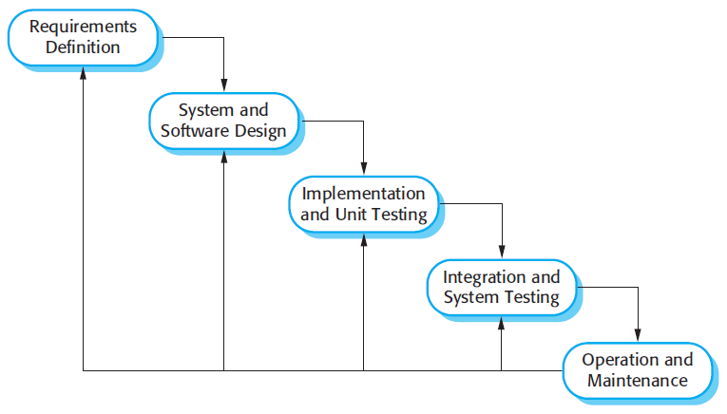

Figure 1 : Waterfall model

Reference: Page 30, chapter 2, Software process model, SOFTWARE ENGINEERING 9th Edition, by Ian Somerville.

* + 1. Roles and responsibilities

|  |  |  |  |
| --- | --- | --- | --- |
| **No** | **Full name** | **Role in Group** | **Responsibilities** |
| 1 | Lại Đức Hùng | Supervisor, Project Manager | * Specify user requirements * Control the development process * Give out technique and business analysis support |
| 2 | Lưu Thành Đạt | Team leader, B.A, Developer, Tester | * Managing process * Designing database * Clarifying requirements * Prepare documents * GUI design * Create test plan * Coding * Testing |
| 3 | Nguyễn Hữu Thắng | Team member,  B.A, Developer,  Tester | * Designing database * Clarifying requirements * Prepare documents * GUI design * Create test plan * Coding * Testing |
| 4 | Phạm Thanh Tùng | Team member,  B.A, Developer,  Tester | * Designing database * Clarifying requirements * Prepare documents * GUI design * Create test plan * Coding |
| 5 | Nguyễn Quang Tuyến | Team member,  B.A, Developer,  Tester | * Clarifying requirements * Prepare documents * Create test plan * Coding * Testing |

Table 5 : Roles and responsibilities

* + 1. Tools and Techniques

|  |  |
| --- | --- |
| **Tool** | **Name / version** |
| Web server | PHP |
| Development tool | IntelliJ IDEA, NetBeans, Android Studio |
| DBMS | MySQL |
| Source control | Github |
| Modeling tool | Star UML v5.0.1 |
| Document tool | Microsoft Word 2016 |

Table 6: Tools List

|  |  |
| --- | --- |
| **Technique** | **Name / version** |
| Frontend | HTML5, CSS, JavaScript, WordPress, Sketch. |
| Backend | Java, Spring Boot, Hibernate, PHP, Android, Retrofit. |

Table 7: Technique List

1. Project Management Plan
2. 1. 1. Software development life cycle

|  |  |  |  |  |  |
| --- | --- | --- | --- | --- | --- |
| **Phase** | **Description** | **Deliverables** | **Resource needed** | **Dependencies and Constrains** | **Risks** |
| Infrastructure | - Identify and clarify overall requirements.  - Determine the system architecture.  - Build infrastructure for the project. | - Database design.  - System main structure. | 20 man-days | N/A | - Unclear project scope.  - Lack of member share of understand. |
| API services | - Identify requirements for mobile app.  - Build required API for mobile app. | - API for mobile app. | 20 man-days | - Depends on “Database Design”. | - Lack of experience. |
| Mobile apps | - Design the mobile UI  - Build mobile apps for end users and emulator. | - Complete Android Apps. | 60 man-days | - Depends on “API services”. | - Lack of experience.  - Lack of Habit Behavior knowledge. |
| Web App | - Implements all web app modules.  - Design the web UI.  - Build the web app. | - Complete Web Apps. | 20 man-days | - Depends on “API services”. | - Lack of experience. |

Table 8: Software Development Life Cycle Detail

* + 1. Phase Detail

  2. 2. 1. Phase 1: Infrastructure

|  |  |  |
| --- | --- | --- |
| **Task** | **Description** | **Author** |
| 1. Assessment | - Determine requirements.  - Determine requirements for System and API. | * DatLT * ThangNH * TuyenNQ * TungPT |
| 2. Selection | - Determine system architecture: Java Web & Android.  - Determine software design pattern: Repository & Service.  - Determined all core functions. | * DatLT * ThangNH * TuyenNQ * TungPT |
| 3. Development | - Create the main structure of project. | * DatLT * ThangNH * TuyenNQ * TungPT |
| 4. Review | - Review all completed works and presentation.  - Create sprint backlog. | * DatLT * TungPT |

Table 9: Phase 1: Infrastructure

* + - 1. Phase 2: Web Service

|  |  |  |
| --- | --- | --- |
| **Task** | **Description** | **Author** |
| 1. Assessment | - Determine requirements for Web service. | * DatLT * ThangNH * TuyenNQ * TungPT |
| 2. Selection | - Determine all functions according to requirements of Web service. | * DatLT * ThangNH * TuyenNQ * TungPT |
| 3. Development | - Create API for mobile app based on functions on the web app. | * DatLT * ThangNH * TuyenNQ * TungPT |
| 4. Review | - Review all completed works and presentation.  - Create sprint backlog. | * DatLT * ThangNH * TuyenNQ * TungPT |

Table 10: Phase 3: Web service

* + - 1. Phase 3: Mobile Application

|  |  |  |
| --- | --- | --- |
| **Task** | **Description** | **Author** |
| 1. Assessment | - Determine requirements for System and Mobile app. | * DatLT * ThangNH * TuyenNQ * TungPT |
| 2. Selection | - Determine all functions according to requirements of Mobile app. | * DatLT * ThangNH * TuyenNQ * TungPT |
| 3. Development | - Implement all the functions based on the designed UI and the provided API. | * DatLT * ThangNH * TuyenNQ * TungPT |
| 4. Review | - Review all completed works and presentation.  - Create sprint backlog. | * DatLT * TungPT |

Table 11: Phase 4: Mobile app

* + 1. All Meeting Minutes

Meeting minutes are contained in folder “Meeting minutes”.

1. Coding Convention

This “Coding Convention” is using for develop project in both Java web admin and Android application:

* Naming Conventions:
* Folders (Java web & Android): folders name are always unique and written in lowercase.

Ex: customer, servlet, sample…

* Packages (Android application): packages/folders name are always unique and written in lowercase.
* Classes/Interfaces: classes or interfaces should be noun, name using Pascal case, in mixed case with the first letter of each internal word capitalized.

Ex: User, ImageSession, CustomerDAO…

* Methods: methods should be verb, name using Camel case, in mixed case with the first letter lower case, with the first of each internal word capitalized.

Ex: run (), crawlNew (), getSearchResults () …

* Variables: name using Camel case, in mixed case with the first letter lower case, with the first of each internal word capitalized. Variable names should not start with underscore _ or dollar sign $ characters, even though both are allowed.

Ex: count, myVariable, isValidated…

* Constants: constants should be all uppercase with words separated by underscores.

Ex: MAX_VALUE, GET_SEARCH_RESULT

* Comment:
* All source files should begin with a comment that lists the class name, description, date, author:

/*

* Class name

*

* Description

*

* Date

*

* Author

*/

* All methods should begin with a comment that lists the method name, description, date, author:

/*

* Method name

*

* Description

*

* Date

*

* Author

*/

* Comment code is 2 slashes “//”
* Comment to explain code need 4 slashes “////”
* Block comment used to provide description of files, methods, structures and algorithms.
* Indentation: Four spaces should be used as the unit of indentation
* Declarations: one declaration per line. Do not put different types on the same line

Ex: int minValue;

1. Software Requirement Specification
2. User Requirement Specification
   * 1. Guest Requirement

Guest is a person who doesn’t have access to the system. Guest can use some functions in the system. To use all functions, guest must login. These are some functions that guest can use:

* Login.
* Register.
  + 1. User Requirement

User is a guest who logged into the system with user’s role. There are some functions that user can use:

* Manage habit:
* Add habit
* View habit
* Edit habit
* Delete habit
* Manage group:
* Add group
* Edit group
* Delete group
* Manage settings:
* Sort habit
* Set reminders
* Export data
* Feedback and contact
* View statistics.
* Sugguest habit.
* View top habit.
* Manage profile.
* Log out.
  + 1. Admin Requirement

Admin is the person who manages the system, a super user of system. There is some functions admin can use:

* Manage users.
* Reset password
* View statistics.
* Manage feedbacks.
* View feedbacks
* Reply feedback

1. System Requirement Specification
   * 1. External Interface Requirement
        1. User Interface

* General requirement for graphic user interface is the GUI should be simple, clear, intuitive, and reminiscent.
* The interface design is an iterated process includes design, sketching and user assessment.
  + - 1. Hardware Interface
* Smartphone, desktop, laptop or tablet has the ability to connect to the internet.
* The system uses the standard hardware and data communications resources of a standard computer.
  + - 1. Software Interface
* Run with Chromes (v60 or higher), Firefox (v46.1 or higher)
* The screen must bigger than 1024x768.
* Mobile application: Android studio (version 3.1.4), Genymotion (version 2.12.2).
  + - 1. Communication Protocol
* Using HTTP/HTTPS protocol.
  + 1. System Overview Use Case

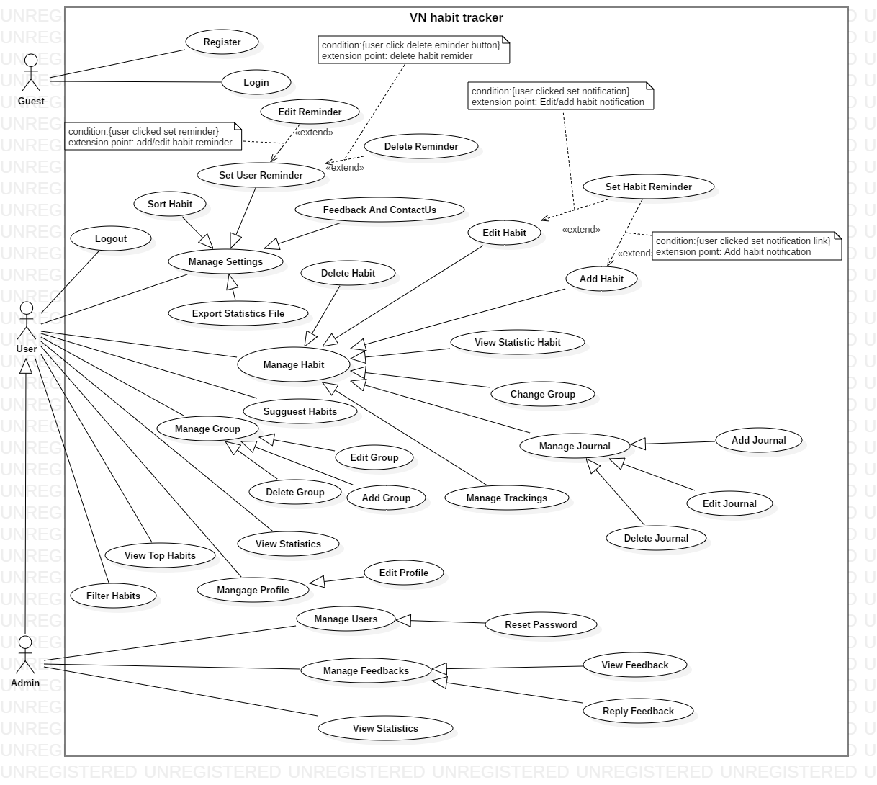

Figure 2- System Overview Use Case Diagram

* + 1. List of Use Case
       1. <Guest> Overview Use Case

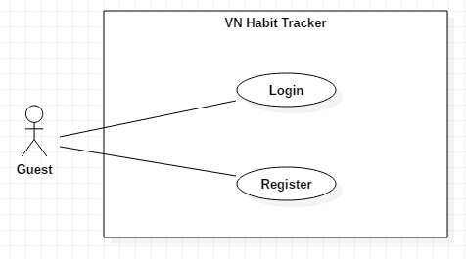

Figure 3- <Guest>Overview Use Case

##### <Guest> Login

**Use Case Diagram**

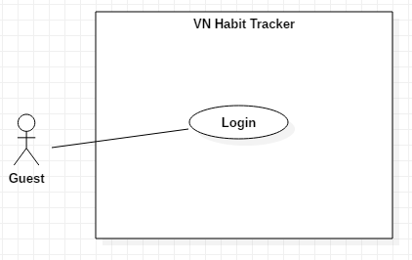

Figure 4 - <Guest> Login

**Use Case Specification**

|  |  |  |  |
| --- | --- | --- | --- |
| **USE CASE – UC_01** | | | |
| **Use Case No.** | 01 | **Use Case Version** | 1.0 |
| **Use Case Name** | Login | | |
| **Author** | ThangNH | | |
| **Date** | 13/11/2018 | **Priority** | Normal |
| **Actor:**   * Guest   **Summary:**   * This use case allows the guest log in the system.   **Goal:**   * Guest logged in the system.   **Triggers:**   * Guest clicks “Đăng nhập” button. * Guest sends the login command.   **Preconditions:**   * Guest at “Đăng nhập” page.   **Post Conditions:**   * **Success:** Guest login the system. * **Fail:** System shows error message.   **Main Success Scenario:**   |  |  |  | | --- | --- | --- | | **Step** | **Actor Action** | **System Response** | | 1 | Guest goes to Login page by clicking “Đăng nhập” button. | System requires information:   * Username: free text input. * Password: free text input. | | 2 | Guest inputs information. |  | | 3 | Guest clicks “Đăng nhập” button. | User login to the system with roles of this account.  [Exception 1,2,3]  [Alternative 1] |   **Alternative:** N/A.  **Exceptions:**   |  |  |  | | --- | --- | --- | | **No** | **Cause** | **System Response** | | 1 | Network problem. | System shows “Đăng nhập không thành công!” message. | | 2 | Username is blank. | System shows “Tên tài khoản rỗng” message. | | 3 | Password is blank. | System shows “Mật khẩu rỗng” message. |   **Relationships:** N/A.  **Business Rules:**   * After logged in, system will redirect to main page. * A notification will be pop-up when user login success. * System must ensure has no duplicate user. * Password must be in rage of 6 – 30 characters. | | | |

Table 12 - <Guest> Login

##### <Guest> Register

**Use Case Diagram**

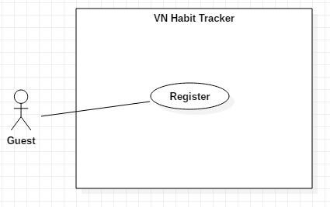

Figure 5 - <Guest> Register

**Use Case Specification**

|  |  |  |  |
| --- | --- | --- | --- |
| **USE CASE – UC_02** | | | |
| **Use Case No.** | 02 | **Use Case Version** | 1.0 |
| **Use Case Name** | Register | | |
| **Author** | ThangNH | | |
| **Date** | 13/11/2018 | **Priority** | Normal |
| **Actor:**   * Guest.   **Summary:**   * This use case allows the guest registers an account.   **Goal:**   * Guest registers an account.   **Triggers:**   * Guest clicks “Đăng ký” button.   **Preconditions:**   * Guest must have an email account. * Guest at “Đăng ký” page.   **Post Conditions:**   * **Success:** System shows “Đăng ký thành công!” message. * **Fail:** System shows “Đăng ký không thành công!” message.   **Main Success Scenario:**   |  |  |  | | --- | --- | --- | | **Step** | **Actor Action** | **System Response** | | 1 | Guest goes to Login page by clicking “Đăng ký” button. | - System requires information:   * Username: text input. * Email: text input. * Password: text input. * Password again: text input. | | 2 | Guest inputs information. |  | | 3 | Guest clicks “Đăng ký” button. | Guest login to the system with roles of this account.  [Exception 1,2,3,4,5,6] |   **Alternative:** N/A  **Exceptions:**   |  |  |  | | --- | --- | --- | | **No** | **Cause** | **System Response** | | 1 | Username is empty. | System shows “Tên tài khoản không được rỗng.” message. | | 2 | Password is empty. | System shows “Mật khẩu không được rỗng.” message. | | 3 | Password is less than 6 character. | System shows “Tên tài khoản không được rỗng.” message. | | 4 | Email is empty. | System shows “Email không được rỗng.” message. | | 5 | Email is wrong format. | System shows “Email không hợp lệ.” message. | | 6 | Network problem. | Show message “Đăng ký không thành công!” |   **Relationships:**  N/A  **Business Rules:**   * After guest registered, system will redirect to login page. * Email must has not duplicate with email is existed. * System must ensure has no duplicate user. * Password must be in rage of 6 – 30 characters. | | | |

Table 13 - <Guest> Register

* + - 1. <User> Overview Use Case

##### <User> Feedback

**Use Case Diagram**

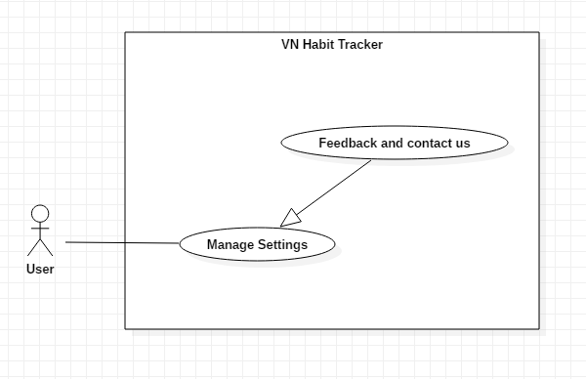

Figure 7 - <User> Feedback and Contact Us

**Use Case Specification**

|  |  |  |  |
| --- | --- | --- | --- |
| **USE CASE – UC_03** | | | |
| **Use Case No.** | 03 | **Use Case Version** | 1.0 |
| **Use Case Name** | Feedback | | |
| **Author** | TuyenNQ | | |
| **Date** | 13/11/2018 | **Priority** | Normal |
| **Actor:**   * User   **Summary:**   * This use case allows the user to feedback.   **Goal:**   * Feedback of the user.   **Triggers:**   * User click on Settings button. * After that, user click on “Feedback” button.   **Preconditions:**   * Guest must login.   **Post Conditions:**   * **Success:** System shows “Gửi feedback thành công!” message. * **Fail:** System shows “Gửi feedback không thành công!” message.   **Main Success Scenario:**   |  |  |  | | --- | --- | --- | | **Step** | **Actor Action** | **System Response** | | 1 | User click on “Feedback” button. | System shows a form for user feedback.  + Name: text input  + Your email: text input  + Message: text input | | 2 | User inputs information. |  | | 3 | User clicks on “Gửi” button. | System validates the information and shows confirmation message.  [Exception 1,2] | | 4 | User click on “Đồng ý” button. | System shows “Gửi feedback thành công” message.  [Exception 3] |   **Alternative:** N/A.  **Exceptions:**   |  |  |  | | --- | --- | --- | | **No** | **Cause** | **System Response** | | 1 | Lost internet. | System shows “Lỗi kết nối!” message. | | 2 | Text blank. | System shows “Không được để trống!” message. | | 3 | User click on “Hủy bỏ” button. | Closed this form. |   **Relationships:**  N/A.  **Business Rules:**   * User rating of the system and what needs improvement. * After feedback success. The user will return to the settings page. * User send feedback about error, bug… on the system. * User ensure enter right email. | | | |

Table 15 - <User> Feedback

##### <User> Set User Reminder

**Use Case Diagram**

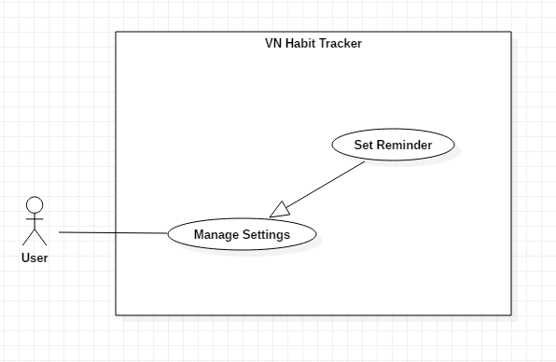

Figure 8 - <User> Set Reminder

**Use Case Specification**

|  |  |  |  |
| --- | --- | --- | --- |
| **USE CASE – UC_04** | | | |
| **Use Case No.** | 04 | **Use Case Version** | 1.0 |
| **Use Case Name** | Set User Reminder | | |
| **Author** | ThangNH | | |
| **Date** | 13/11/2018 | **Priority** | Normal |
| **Actor:**   * User   **Summary:**   * This use case allows the user set a reminder for system.   **Goal:**   * Set reminder for system.   **Triggers:**   * User clicks on Settings button. * After that, user clicks on Reminder button.   **Preconditions:**   * Guest must login.   **Post Conditions:**   * **Success:** System shows list of the reminder. * **Fail:** System not show list of the reminder.   **Main Success Scenario:**   |  |  |  | | --- | --- | --- | | **Step** | **Actor Action** | **System Response** | | 1 | User clicks on Reminder button. | - System shows a form for use set reminder.   * Nội dung nhắc nhở: text input * Chọn ngày và giờ: datetime * Lặp lại. | | 2 | User sets in this form. |  | | 3 | User click on “Lưu lại” button. | - The system validates the information and reponse result.  [Exception 1] |   **Alternative:** N/A.  **Exceptions:**   |  |  |  | | --- | --- | --- | | **No** | **Cause** | **System Response** | | 1 | User click on “Hủy bỏ” button. | Closed Reminder page. |   **Relationships:**  N/A  **Business Rules:**   * After setting reminder success. The user will return to the settings page. * Only use sound default to set reminder. * The system will notify the user on time. * User can set many reminders for the application. | | | |

Table 16 - <User> Set Reminder

##### <User> Edit User Reminder

**Use Case Diagram**

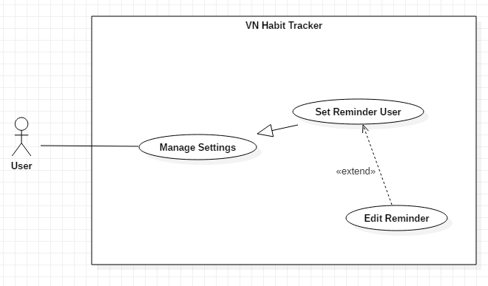

Figure 9 - <User> Edit Reminder

**Use Case Specification**

|  |  |  |  |
| --- | --- | --- | --- |
| **USE CASE – UC_05** | | | |
| **Use Case No.** | 05 | **Use Case Version** | 1.0 |
| **Use Case Name** | Edit User Reminder | | |
| **Author** | ThangNH | | |
| **Date** | 13/11/2018 | **Priority** | Normal |
| **Actor:**   * User   **Summary:**   * This use case allows the user edit a reminder for system.   **Goal:**   * Edit reminder for system.   **Triggers:**   * User click on Settings button. * User click on Reminder button.   **Preconditions:**   * Guest must login.   **Post Conditions:**   * **Success:** System shows list of the reminder. * **Fail:** System not show list of the reminder.   **Main Success Scenario:**   |  |  |  | | --- | --- | --- | | **Step** | **Actor Action** | **System Response** | | 1 | User click on Reminder button. | The system shows a form for use set reminder.  + Nội dung nhắc nhở: text input  + Chọn ngày và giờ: datetime  + Lặp lại. | | 2 | User sets in this form. |  | | 3 | User click on “Cập nhật” button. | - The system validates the information and reponse result.  [Exception 1] |   **Alternative:** N/A.  **Exceptions:**   |  |  |  | | --- | --- | --- | | **No** | **Cause** | **System Response** | | 1 | User click on “Hủy bỏ” button. | Closed Reminder page. |   **Relationships:** Extent from Set Reminder User use case.  **Business Rules:**   * After update reminder success. The user will return to the settings page. * The system notifies the user on time. * User reset reminders when the habit changes. | | | |

Table 17 - <User> Edit Reminder

##### <User> Delete User Reminder

**Use Case Diagram**

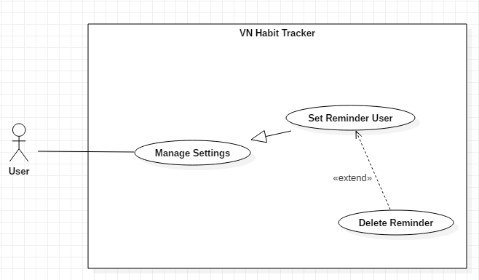

Figure 10 - <User> Delete User Reminder

**Use Case Specification**

|  |  |  |  |
| --- | --- | --- | --- |
| **USE CASE – UC_06** | | | |
| **Use Case No.** | 06 | **Use Case Version** | 1.0 |
| **Use Case Name** | Delete User Reminder | | |
| **Author** | ThangNH | | |
| **Date** | 13/11/2018 | **Priority** | Normal |
| **Actor:**   * User   **Summary:**   * This use case allows the user delete a reminder for system.   **Goal:**   * Delete a reminder of the system.   **Triggers:**   * User click on Settings button. * User click on Reminder button.   **Preconditions:**   * Guest must login.   **Post Conditions:**   * **Success:** System shows list of user’s reminders without this reminder have been deleted.   **Fail:** System not delete user’s reminder.  **Main Success Scenario:**   |  |  |  | | --- | --- | --- | | **Step** | **Actor Action** | **System Response** | | 1 | User clicks on Reminder button. | The system shows a list of user’s reminders that user delete reminder. | | 2 | User click on “Xóa bỏ” button. | - The system validates the information and shows confirmation message.  [Exception 1] | | 3 | User click “Có” button. | The system deleted this reminder. |   **Alternative:** N/A  **Exception:**   |  |  |  | | --- | --- | --- | | **No** | **Actor Action** | **System Response** | | 1 | User click on “Không” button. | Closed Reminder page. |   **Relationships:**  Extent from Set Reminder User use case.  **Business Rules:**   * After deleted reminder success. The user will return to the settings page. * When this reminder doesn’t need for user. | | | |

Table 18 - <User> Delete reminder

##### <User> Export statistic file

**Use Case Diagram**

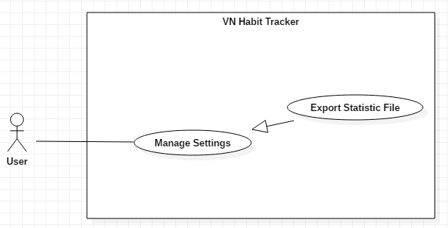

Figure 11 - <User> Export Statistic File

**Use Case Specification**

|  |  |  |  |
| --- | --- | --- | --- |
| **USE CASE – UC_07** | | | |
| **Use Case No.** | 07 | **Use Case Version** | 1.0 |
| **Use Case Name** | Export Statistic File | | |
| **Author** | TuyenNQ | | |
| **Date** | 13/11/2018 | **Priority** | Normal |
| **Actor:**   * User   **Summary:**   * This use case allows the user to export statistic.   **Goal:**   * Export file CSV.   **Triggers:**   * User click on Settings button. * User click on “Xuất file” button.   **Preconditions:**   * Guest must login. * User must have at least one habit.   **Post Conditions:**   * **Success:** System shows “Đã xuất file.” message. * **Fail:** System shows “Xuất file không thành công!” message.   **Main Success Scenario:**   |  |  |  | | --- | --- | --- | | **Step** | **Actor Action** | **System Response** | | 1 | User click on “Xuất file” button. | System shows “Bạn muốn xuất file?” message. | | 2 | User click on “Đồng ý” button. | System shows “Đã xuất file.” message.  [Exception 1] |   **Alternative:** N/A.  **Exceptions:**   |  |  |  | | --- | --- | --- | | **No** | **Cause** | **System Response** | | 1 | User click on “Hủy bỏ” button. | Closed this form. |   **Relationships:**  N/A  **Business Rules:**   * After Export file success. The system output .csv file and user return to the settings page. * This file CSV save on device. * File CSV show all information of user’s habits. | | | |

Table 19 - <User> Export Statistic File

##### <User> Add Habit

**Use Case Diagram**

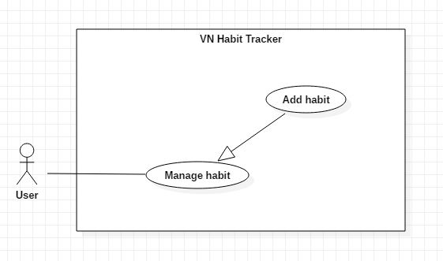

Figure 12 - <User> Add Habit

**Use Case Specification**

|  |  |  |  |
| --- | --- | --- | --- |
| **USE CASE – UC_08** | | | |
| **Use Case No.** | 08 | **Use Case Version** | 1.0 |
| **Use Case Name** | Add Habit | | |
| **Author** | TungPT | | |
| **Date** | 14/11/2018 | **Priority** | Normal |
| **Actor:**   * User   **Summary:**   * This use case allows the user to add a habit.   **Goal:**   * Add a habit.   **Triggers:**   * User click on Add Habit button.   **Preconditions:**   * Guest must login.   **Post Conditions:**   * **Success:** The system displays the habit that is created. * **Fail:** The system not display the habit that is created.   **Main Success Scenario:**   |  |  |  | | --- | --- | --- | | **Step** | **Actor Action** | **System Response** | | 1 | User clicks on Add Habit button. | - System request information in form:   * Tên thói quen: text input. * Đề xuất: button. * Xây dựng hay từ bỏ: select button. * Loại mục tiêu: select option. * Cách theo dõi: select button. * Nhóm thói quen: list group item. * Ngày theo dõi trong tuần: select button. * Thời gian thực hiện: check button. * Màu thói quen: select color. * Nhắc nhở: list reminder item. * Động lực: text input. | | 2 | User inputs information. |  | | 2 | User clicks on “Lưu lại” button. | - System validates the information and shows result in the main page.  [Exception 1, 2]  - This habit is created. |   **Alternative:** N/A.  **Exceptions:**   |  |  |  | | --- | --- | --- | | **No** | **Cause** | **System Response** | | 1 | Name habit is blank. | System shows “Tên thói quen không được rỗng” message. | | 2 | User clicks on Back button. | - Closed habit page. |   **Relationships:**  Add group, Set notification.  **Business Rules:**   * The habit’s name must be under 255 characters and not null. * After adding habit success. The user returns to the habit page. * The Habit displayed on the main screen with the date the user has selected. * In next day, daily habits reset. * In next week, weekly habits reset. * In next month, monthly habits reset. * In next year, yearly habits reset. | | | |

Table 20 - <User> Add Habit

##### <User> Delete Habit

**Use Case Diagram**

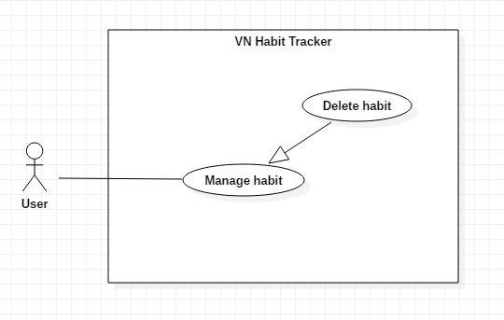

Figure 13 - <User> Delete Habit

**Use Case Specification**

|  |  |  |  |
| --- | --- | --- | --- |
| **USE CASE – UC_09** | | | |
| **Use Case No.** | 09 | **Use Case Version** | 1.0 |
| **Use Case Name** | Delete Habit | | |
| **Author** | TungPT | | |
| **Date** | 14/11/2018 | **Priority** | Normal |
| **Actor:**   * User   **Summary:**   * This use case allows the user to delete a habit.   **Goal:**   * Delete a habit.   **Triggers:**   * User clicks into the habit. * User clicks on “Xóa” button.   **Preconditions:**   * Guest must login. * The habit is existed.   **Post Conditions:**   * **Success:** System shows “Đã xóa thói quen!” message. * **Fail:** System shows “Xóa thói quen không thành công!” message.   **Main Success Scenario:**   |  |  |  | | --- | --- | --- | | **Step** | **Actor Action** | **System Response** | | 1 | User clicks into the habit. | System shows the habit detail page:   * Chart Habit button. * Edit Habit button. * Journal button. * Calendar button. * Display Chart of this habit. | | 2 | User clicks on Edit Habit button. | The system request information in form:   * Tên thói quen: text input. * Đề xuất: button. * Xây dựng hay từ bỏ: select button. * Loại mục tiêu: select option. * Cách theo dõi: select button. * Nhóm thói quen: list group item. * Ngày theo dõi trong tuần: select button. * Thời gian thực hiện: check button. * Màu thói quen: select color. * Nhắc nhở: list reminder item. * Động lực: text input. | | 2 | User clicks on “Xóa” button. | - System validates the information and shows result in the main page.  [Exception 1]  - System shows “Đã xóa thói quen” message. |   **Alternative:** N/A.  **Exceptions:**   |  |  |  | | --- | --- | --- | | **No** | **Cause** | **System Response** | | 1 | User clicks on Back icon. | - Closed habit page. |   **Relationships:**  N/A  **Business Rules:**   * When a user deleted a habit, this habit will be deleted on the server. * The information of the habit is also deleted on the local. * After deleted habit success. The user returns to the habit detail page. | | | |

Table 21 - <User> Delete Habit

##### <User> Edit Habit

**Use Case Diagram**

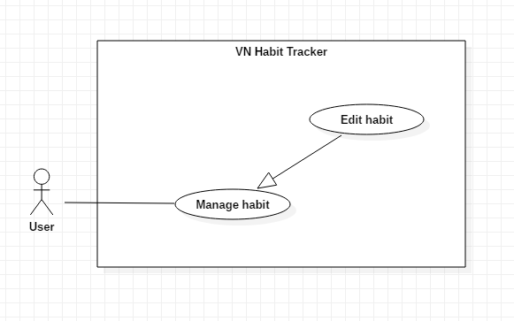

Figure 14 - <User> Edit Habit

**Use Case Specification**

|  |  |  |  |
| --- | --- | --- | --- |
| **USE CASE – UC_10** | | | |
| **Use Case No.** | 10 | **Use Case Version** | 1.0 |
| **Use Case Name** | Edit Habit | | |
| **Author** | TungPT | | |
| **Date** | 14/11/2018 | **Priority** | Normal |
| **Actor:**   * User   **Summary:**   * This use case allows the user to edit a habit.   **Goal:**   * Edit habit when user input.   **Triggers:**   * User clicks into the habit. * User clicks on Edit Habit button.   **Preconditions:**   * Guest must login. * The habit is existed.   **Post Conditions:**   * **Success:** System shows “Cập nhật thói quen thành công!” message. * **Fail:** System shows “Cập nhật thói quen không thành công!” message.   **Main Success Scenario:**   |  |  |  | | --- | --- | --- | | **Step** | **Actor Action** | **System Response** | | 1 | User clicks into the habit. | - System shows the habit detail page:   * Chart Habit button. * Edit Habit button. * Journal button. * Calendar button. * Display Chart of this habit. | | 2 | User clicks on Edit Habit button. | - System request information in form:   * Tên thói quen: text input. * Đề xuất: button. * Xây dựng hay từ bỏ: select button. * Loại mục tiêu: select option. * Cách theo dõi: select button. * Nhóm thói quen: list group item. * Ngày theo dõi trong tuần: select button. * Thời gian thực hiện: check button. * Màu thói quen: select color. * Nhắc nhở: list reminder item. * Động lực: text input. | | 3 | User edits required field. |  | | 4 | User clicks on “Cập nhật” button. | - System validates the information and shows result in the main page.  [Exception 1]  - System shows “Đã cập nhật thói quen” message. |   **Alternative:** N/A.  **Exceptions:**   |  |  |  | | --- | --- | --- | | **No** | **Cause** | **System Response** | | 1 | Name habit is blank. | The system shows “Tên thói quen không được trống!” message. | | 2 | User clicks on Back button. | - Closed habit page. | |  |  |  |   **Relationships:**  N/A  **Business Rules:**   * The habit’s name must be under 255 characters and not null. * The information of Habit will be sent to the server. * After Edit habit success. The user will return to the habit detail page. * User can change information of the habit if this habit is difficult to implement. | | | |

Table 22 - <User> Edit Habit

##### <User> Set Reminder Habit

**Use Case Diagram**

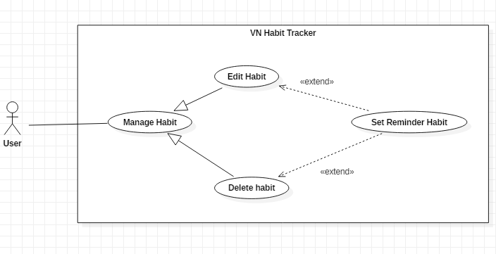

Figure 15 - <User> Set Reminder Habit

**Use Case Specification**

|  |  |  |  |
| --- | --- | --- | --- |
| **USE CASE – UC_11** | | | |
| **Use Case No.** | 11 | **Use Case Version** | 1.0 |
| **Use Case Name** | Set Reminder Habit | | |
| **Author** | ThangNH | | |
| **Date** | 13/11/2018 | **Priority** | Normal |
| **Actor:**   * User   **Summary:**   * This use case allows the user to set the notification.   **Goal:**   * Set reminder for a habit.   **Triggers:**   * User clicks on Add Habit button or Edit Habit button. * User clicks on Reminder button.   **Preconditions:**   * Guest must login.   **Post Conditions:**   * **Success:** Mobile devices show the pop-up with sound. * **Fail:** System does not show pop-up.   **Main Success Scenario:**   |  |  |  | | --- | --- | --- | | **Step** | **Actor Action** | **System Response** | | 1 | User clicks on Add Habit button.  [Alternative 1] | - System request information in form:   * Tên thói quen: text input. * Đề xuất: button. * Xây dựng hay từ bỏ: select button. * Loại mục tiêu: select option. * Cách theo dõi: select button. * Nhóm thói quen: list group item. * Ngày theo dõi trong tuần: select button. * Thời gian thực hiện: check button. * Màu thói quen: select color. * Nhắc nhở: list reminder item. * Động lực: text input. | | 2 | User clicks on Reminder button. | - System shows a form for user set habit’s reminder:   * Nội dung nhắc nhở: text input * Chọn ngày và giờ: datetime   Lặp lại. | | 3 | User clicks on “Lưu lại” button. | System validates the request and shows result in the habit page.  [Exception 1] |   **Alternative:**   |  |  |  | | --- | --- | --- | | **No** | **Actor Action** | **System Response** | | 1 | User clicks on Edit Habit button. | - The ystem request information in form:   * Tên thói quen: text input. * Đề xuất: button. * Xây dựng hay từ bỏ: select button. * Loại mục tiêu: select option. * Cách theo dõi: select button. * Nhóm thói quen: list group item. * Ngày theo dõi trong tuần: select button. * Thời gian thực hiện: check button. * Màu thói quen: select color. * Nhắc nhở: list reminder item. * Động lực: text input. |   **Exceptions:**   |  |  |  | | --- | --- | --- | | **No** | **Cause** | **System Response** | | 1 | User click on “Hủy bỏ” button. | Closed habit’s reminder page. |   **Relationships:**  Extent from Edit Habit, Add Habit use case.  **Business Rules:**   * The habit must be existed first. * After set notification successfully. The user will see the notification of the habit when time comes. * Reminder habit will pop-up when time comes. | | | |

Table 23 - <User> Set Reminder Habit

##### <User> View Statistic Habit

**Use Case Diagram**

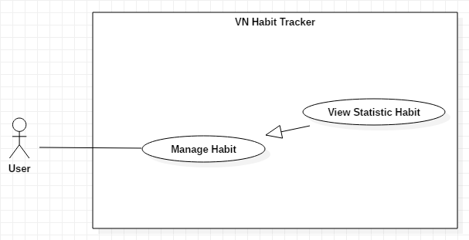

Figure 16 - <User> View Statistic Habit

**Use Case Specification**

|  |  |  |  |
| --- | --- | --- | --- |
| **USE CASE – UC_12** | | | |
| **Use Case No.** | 12 | **Use Case Version** | 1.0 |
| **Use Case Name** | View Statistic Habit | | |
| **Author** | DatLT | | |
| **Date** | 14/11/2018 | **Priority** | Normal |
| **Actor:**   * User   **Summary:**   * This use case allows the user view statistic detail of the habit.   **Goal:**   * View statistic detail of the habit.   **Triggers:**   * User clicks into the habit. * User clicks on view habit detail.   **Preconditions:**   * Guest must login. * The user must have at least one habit.   **Post Conditions:**   * **Success:** Statistic detail have been displayed. * **Fail:** Statistic detail haven’t been displayed.   **Main Success Scenario:**   |  |  |  | | --- | --- | --- | | **Step** | **Actor Action** | **System Response** | | 1 | User clicks into the habit. | - System shows the habit detail page:   * Chart Habit button. * Edit Habit button. * Journal button. * Calendar button. * Chart of this habit. |   **Alternative:** N/A.  **Exceptions:** N/A.  **Relationships:**  N/A.  **Business Rules:**   * After view statistic detail successfully. The user will return to the main page. * User can view another added habit. * User can see the details of a habit. * Habits of users will be represented on the chart follow:   + Week  + Month  + Year | | | |

Table 24 - <User> View Statistic Habit

##### <User> Add Journal

**Use Case Diagram**

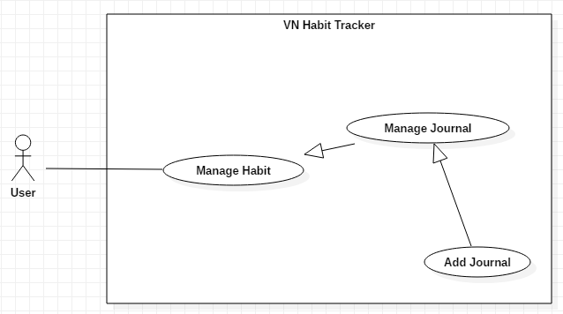

Figure 17 - <User> Add Journal

**Use Case Specification**

|  |  |  |  |
| --- | --- | --- | --- |
| **USE CASE – UC_13** | | | |
| **Use Case No.** | 13 | **Use Case Version** | 1.0 |
| **Use Case Name** | Add Journal | | |
| **Author** | DatLT | | |
| **Date** | 13/11/2018 | **Priority** | Normal |
| **Actor:**   * User   **Summary:**   * This use case allows the user adds new journal.   **Goal:**   * User add new journal.   **Triggers:**   * User clicks into the habit. * User clicks on Journal button.   **Preconditions:**   * Guest must login. * The habit is existed.   **Post Conditions:**   * **Success:** Journal is displayed. * **Fail:** Journal isn’t displayed.   **Main Success Scenario:**   |  |  |  | | --- | --- | --- | | **Step** | **Actor Action** | **System Response** | | 1 | User clicks on journal button. | System shows a list of notes. | | 2 | User clicks on Add button. | System shows the form have text box to write in. | | 3 | User inputs information. |  | | 4 | User clicks on “Lưu” button. | System validates the request and shows result in the habit page.  [Exception 1, 2] |   **Alternative:** N/A.  **Exceptions:**   |  |  |  | | --- | --- | --- | | **No** | **Cause** | **System Response** | | 1 | Text box is blank. | System shows “Ghi chú không được rỗng!” Message. | | 2 | User click on “Hủy” button. | Closed this form. |   **Relationships:**  Extent from Manage Journal use case.  **Business Rules:**   * After add a new journal successfully. The user will return to the journal page. * User add another journal follow day, week, month, year. * Users note the process of this habit. | | | |

Table 25 - <User> Add Journal

##### <User> Edit Journal

**Use Case Diagram**

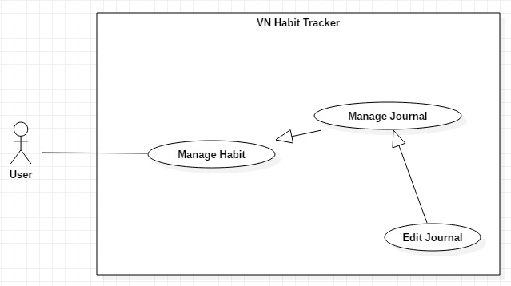

Figure 18 - <User> Edit Journal

**Use Case Specification**

|  |  |  |  |
| --- | --- | --- | --- |
| **USE CASE – UC_14** | | | |
| **Use Case No.** | 14 | **Use Case Version** | 1.0 |
| **Use Case Name** | Edit Journal | | |
| **Author** | DatLT | | |
| **Date** | 13/11/2018 | **Priority** | Normal |
| **Actor:**   * User   **Summary:**   * This use case allows the user edits a journal.   **Goal:**   * User edits a journal.   **Triggers:**   * User clicks into the habit. * User clicks on journal button.   **Preconditions:**   * Guest must login. * The habit is existed.   **Post Conditions:**   * **Success:** Journal is displayed. * **Fail:** Journal isn’t displayed.   **Main Success Scenario:**   |  |  |  | | --- | --- | --- | | **Step** | **Actor Action** | **System Response** | | 1 | User clicks on journal button. | System shows a list of notes. | | 2 | User clicks on the note want to edit. | System shows the form have text box to edit. | | 3 | User inputs information. |  | | 4 | User clicks on “Lưu” button. | System validates the request and shows result in the habit page.  [Exception 1] |   **Alternative:** N/A.  **Exceptions:**   |  |  |  | | --- | --- | --- | | **No** | **Cause** | **System Response** | | 1 | User click on “Xóa” button. | Closed this form. |   **Relationships:**  Extent from Manage Journal use case.  **Business Rules:**   * After edit a journal successfully. The user will return to the journal page. * User can edit another journal. * Users note the process of this habit. | | | |

Table 26 - <User> Edit Journal

##### <User> Delete Journal

**Use Case Diagram**

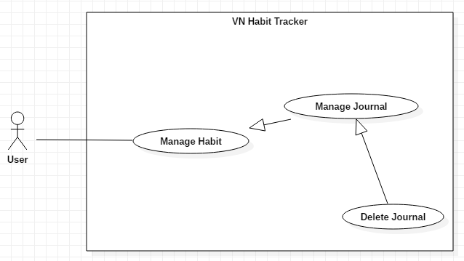

Figure 19 - <User> Delete Journal

**Use Case Specification**

|  |  |  |  |
| --- | --- | --- | --- |
| **USE CASE – UC_15** | | | |
| **Use Case No.** | 15 | **Use Case Version** | 1.0 |
| **Use Case Name** | Delete Journal | | |
| **Author** | DatLT | | |
| **Date** | 13/11/2018 | **Priority** | Normal |
| **Actor:**   * User   **Summary:**   * This use case allows the user deletes a journal.   **Goal:**   * User delete a journal.   **Triggers:**   * User clicks into the habit. * User click on journal button.   **Preconditions:**   * Guest must login. * The habit is existed.   **Post Conditions:**   * **Success:** Journal is displayed. * **Fail:** Journal isn’t displayed.   **Main Success Scenario:**   |  |  |  | | --- | --- | --- | | **Step** | **Actor Action** | **System Response** | | 1 | User clicks on journal button. | System shows a list of notes. | | 2 | User clicks on the note want to delete. | System shows the form have text box. | | 3 | User clicks on “Xóa” button. | System validates the request and shows result in the habit page.  [Exception 1] |   **Alternative:** N/A.  **Exceptions:**   |  |  |  | | --- | --- | --- | | **No** | **Cause** | **System Response** | | 1 | User clicks outside form. | Closed this form. |   **Relationships:**  N/A  **Business Rules:**   * After delete a journal successfully. The user will return to the journal page. * User can delete another journal. | | | |

Table 27 - <User> Delete Journal

##### <User> Add Group

**Use Case Diagram**

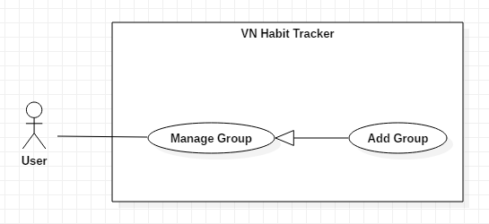

Figure 20 - <User> Add Group

**Use Case Specification**

|  |  |  |  |
| --- | --- | --- | --- |
| **USE CASE – UC_16** | | | |
| **Use Case No.** | 16 | **Use Case Version** | 1.0 |
| **Use Case Name** | Add Group | | |
| **Author** | TuyenNQ | | |
| **Date** | 13/11/2018 | **Priority** | Normal |
| **Actor:**   * User   **Summary:**   * This use case allows the user to add group.   **Group:**   * Add a group while add the habit.   **Triggers:**   * User clicks on Add Habit button or Edit Habit button. * User clicks on Group button.   **Preconditions:**   * Guest must login.   **Post Conditions:**   * **Success:** New group is display in group’s list. * **Fail:** New group isn’t display in group’s list.   **Main Success Scenario:**   |  |  |  | | --- | --- | --- | | **Step** | **Actor Action** | **System Response** | | 1 | User on Add Habit button.  [Alternative 1] | - System request information in form:   * Tên thói quen: text input. * Đề xuất: button. * Xây dựng hay từ bỏ: select button. * Loại mục tiêu: select option. * Cách theo dõi: select button. * Nhóm thói quen: list group item. * Ngày theo dõi trong tuần: select button. * Thời gian thực hiện: check button. * Màu thói quen: select color. * Nhắc nhở: list reminder item. * Động lực: text input. | | 2 | User click on Group button. | - System shows group page:   * List of the group’s item. * Name group: Text. * Add button. | | 3 | User inputs information. |  | | 4 | User clicks on Add button. | - System validates the information and shows result in the group page.  [Exception 1, 2]  - This group is added. |   **Alternative:**   |  |  |  | | --- | --- | --- | | **No** | **Actor Action** | **System Response** | | 1 | User clicks on Edit Habit button. | - System request information in form:   * Tên thói quen: text input. * Đề xuất: button. * Xây dựng hay từ bỏ: select button. * Loại mục tiêu: select option. * Cách theo dõi: select button. * Nhóm thói quen: list group item. * Ngày theo dõi trong tuần: select button. * Thời gian thực hiện: check button. * Màu thói quen: select color. * Nhắc nhở: list reminder item. * Động lực: text input. |   **Exceptions:**   |  |  |  | | --- | --- | --- | | **No** | **Cause** | **System Response** | | 1 | Group name is blank. | Shows “Tên nhóm không được trống!” message. | | 2 | User click on Back button. | Closed group page. |   **Relationships:**  N/A  **Business Rules:**   * The group name must be under 255 characters and not null. * After adding group success. The user returns habit page. * A habit have many groups. | | | |

Table 28 - <User> Add Group

##### <User> Delete Group

**Use Case Diagram**

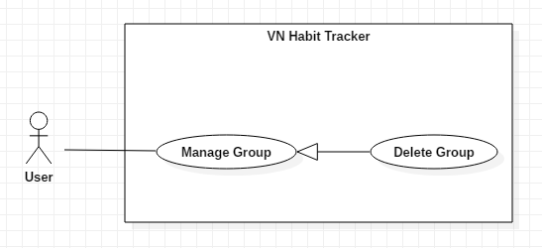

Figure 21 - <User> Delete Group

**Use Case Specification**

|  |  |  |  |
| --- | --- | --- | --- |
| **USE CASE – UC_17** | | | |
| **Use Case No.** | 17 | **Use Case Version** | 1.0 |
| **Use Case Name** | Delete Group | | |
| **Author** | TuyenNQ | | |
| **Date** | 13/11/2018 | **Priority** | Normal |
| **Actor:**   * User   **Summary:**   * This use case allows the user to delete group.   **Group:**   * Delete a group from the group.   **Triggers:**   * User clicks on Add Habit button or Edit Habit button. * User clicks on Group button.   **Preconditions:**   * Guest must login.   **Post Conditions:**   * **Success:** System shows “Xóa nhóm thành công!” message. * **Fail:** System shows “Xóa nhóm không thành công!” message.   **Main Success Scenario:**   |  |  |  | | --- | --- | --- | | **Step** | **Actor Action** | **System Response** | | 1 | User click on “Xóa nhóm” button. | Shows a form to ask user want to delete group. | | 2 | User click on “Xóa” button.  [Alternative 1] | - The system validates the request and shows the added information.  [Exception 1] | | 3 | User click on “Lưu” button. | - That group will be deleted. |   **Alternative:**   |  |  |  | | --- | --- | --- | | **No** | **Actor Action** | **System Response** | | 1 | User click on “Hủy bỏ” button. | - Closed this form. |   **Exceptions:**   |  |  |  | | --- | --- | --- | | **No** | **Cause** | **System Response** | | 1 | None of any group was selected. | Shows “Không có nhóm để xóa!” message. |   **Relationships:**  N/A  **Business Rules:**   * The user only deletes the group created by himself. * When a user deleted a group, this group will be deleted on the server. * The information of the group is also deleted to the local. * After deleted group success. The user returns to the main page. | | | |

Table 29 - <User> Delete Group

##### <User> Edit Group

**Use Case Diagram**

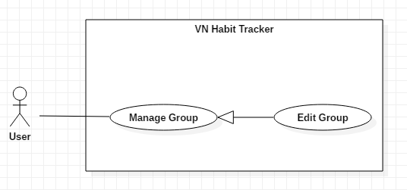

Figure 22 - <User> Edit Group

**Use Case Specification**

|  |  |  |  |
| --- | --- | --- | --- |
| **USE CASE – UC_18** | | | |
| **Use Case No.** | 18 | **Use Case Version** | 1.0 |
| **Use Case Name** | Edit Group | | |
| **Author** | TuyenNQ | | |
| **Date** | 07/10/2018 | **Priority** | Normal |
| **Actor:**   * User   **Summary:**   * This use case allows the user to edit a group.   **Group:**   * Edit a group.   **Triggers:**   * User clicks on Add Habit button or Edit Habit button. * User clicks on Group button.   **Preconditions:**   * Guest must login.   **Post Conditions:**   * **Success:** System shows “Cập nhật nhóm thành công!” message. * **Fail:** System shows “Cập nhật nhóm thất bại!” message.   **Main Success Scenario:**   |  |  |  | | --- | --- | --- | | **Step** | **Actor Action** | **System Response** | | 1 | User click on group button. | The system shows a form that have list group. | | 2 | User click on “Cập nhật” button.  [Alternative 1] | - The system validates the request and shows the added information.  [Exception 1] | | 3 | User click on “Lưu” button. | - That group will be edited. |   **Alternative:**   |  |  |  | | --- | --- | --- | | **No** | **Actor Action** | **System Response** | | 1 | User click on “Hủy bỏ” button. | - Closed this form. |   **Exceptions:**   |  |  |  | | --- | --- | --- | | **No** | **Cause** | **System Response** | | 1 | None of any group was selected. | Shows “Không có nhóm nào để sửa!” message. |   **Relationships:**  N/A  **Business Rules:**   * The group name must be under 255 characters and not null. * The information of Group is sent to the server. * After Edit group success. The user will return to the menu list habit page. | | | |

Table 30 - <User> Edit Group

##### <User> Edit Profile

**Use Case Diagram**

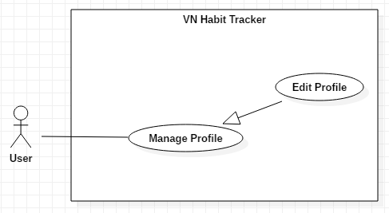

Figure 23 - <User> Edit Profile

**Use Case Specification**

|  |  |  |  |
| --- | --- | --- | --- |
| **USE CASE – UC_19** | | | |
| **Use Case No.** | 19 | **Use Case Version** | 1.0 |
| **Use Case Name** | Edit Profile | | |
| **Author** | DatLT | | |
| **Date** | 13/11/2018 | **Priority** | Normal |
| **Actor:**   * User   **Summary:**   * This use case allows the user to edit profile.   **Group:**   * Edit profile of the user.   **Triggers:**   * User clicks on Settings button. * User clicks on “Thông tin” button. * User clicks on “Cập nhật thông tin” button.   **Preconditions:**   * Guest must login.   **Post Conditions:**   * **Success:** System shows “Cập nhật thông tin thành công!” message. * **Fail:** System shows “Cập nhật thông tin không thành công!” message.   **Main Success Scenario:**   |  |  |  | | --- | --- | --- | | **Step** | **Actor Action** | **System Response** | | 1 | User click on “Cập nhật thông tin” button. | The system request information in form:   * Tên: text input * Email: text input * Age: number input * Phone: number input | | 2 | User click on “Cập nhật” button | - The system validates the request and shows the added information.  [Exception 1, 2] | | 3 | User click on “Lưu” button. | That information about the user will be edited. |   **Alternative:** N/A.  **Exceptions:**   |  |  |  | | --- | --- | --- | | **No** | **Cause** | **System Response** | | 1 | Name is empty. | Shows “Tên không được bỏ trống!” message. | | 2 | User click on “Hủy bỏ” button. | Closed this form. |   **Relationships:**  N/A  **Business Rules:**   * Name user not null. * The information of User is sent to the server. * After Edit profile success. The user will return to the profile page. | | | |

Table 31 - <User> Edit Profile

##### <User> Suggest Habit

**Use Case Diagram**

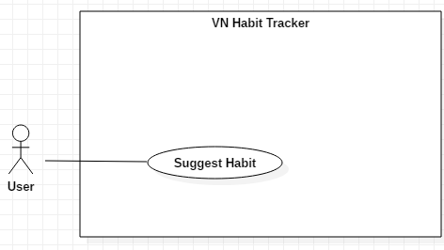

Figure 24 - <User> Suggest Habit

**Use Case Specification**

|  |  |  |  |
| --- | --- | --- | --- |
| **USE CASE – UC_20** | | | |
| **Use Case No.** | 20 | **Use Case Version** | 1.0 |
| **Use Case Name** | Suggest Habit | | |
| **Author** | DatLT | | |
| **Date** | 13/11/2018 | **Priority** | Normal |
| **Actor:**   * User   **Summary:**   * This use case allows the user will suggest from the application.   **Group:**   * Suggest for the user.   **Triggers:**   * User click on Add Habit button or Edit Button. * User click on “Đề xuất” button.   **Preconditions:**   * Guest must login.   **Post Conditions:**   * **Success:** System shows success message. * **Fail:** System shows error message.   **Main Success Scenario:**   |  |  |  | | --- | --- | --- | | **Step** | **Actor Action** | **System Response** | | 1 | User click on Add Habit button. | The system request information in form:   * Tên thói quen: text input. * Đề xuất: button. * Xây dựng hay từ bỏ: select button. * Loại mục tiêu: select option. * Cách theo dõi: select button. * Nhóm thói quen: list group item. * Ngày theo dõi trong tuần: select button. * Thời gian thực hiện: check button. * Màu thói quen: select color. * Nhắc nhở: list reminder item. * Động lực: text input. | | 2 | User click on “Đề xuất” button. | The system request information in form: list the habits with level of the user. |   **Alternative:**   |  |  |  | | --- | --- | --- | | **No** | **Cause** | **System Response** | | 1 | User click on Edit Habit button. | The system request information in form:   * Tên thói quen: text input. * Đề xuất: button. * Xây dựng hay từ bỏ: select button. * Loại mục tiêu: select option. * Cách theo dõi: select button. * Nhóm thói quen: list group item. * Ngày theo dõi trong tuần: select button. * Thời gian thực hiện: check button. * Màu thói quen: select color. * Nhắc nhở: list reminder item. * Động lực: text input. |   **Relationships:**  N/A  **Business Rules:**   * The information about the habit of the user is sent to the server. * After suggest habit success. The user will return to the add habit page. * User will be suggested follow level of user: easy, average and hard. | | | |

Table 32 - <User> Suggest Habit

##### <User> Filter Habits

**Use Case Diagram**

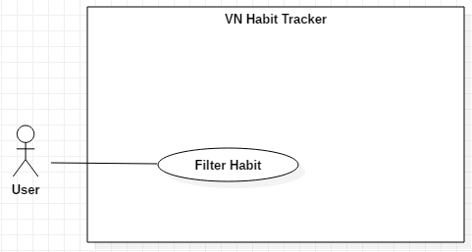

Figure 25 - <User> Filter Habit

**Use Case Specification**

|  |  |  |  |
| --- | --- | --- | --- |
| **USE CASE – UC_21** | | | |
| **Use Case No.** | 21 | **Use Case Version** | 1.0 |
| **Use Case Name** | Filter Habit | | |
| **Author** | DatLT | | |
| **Date** | 13/11/2018 | **Priority** | Normal |
| **Actor:**   * User   **Summary:**   * This use case allows the user want to filter habit.   **Group:**   * Filter habit.   **Triggers:**   * User click on filter button.   **Preconditions:**   * Guest must login.   **Post Conditions:**   * **Success:** System displayed filter detail. * **Fail:** System not displayed filter detail.   **Main Success Scenario:**   |  |  |  | | --- | --- | --- | | **Step** | **Actor Action** | **System Response** | | 1 | User clicks on filter button. | - System request information in form:   * Loại mục tiêu: check box. * Loại thói quen: check box. * Nhóm: list item. | | 2 | User click on “Áp dụng” button.  [Exception 1] | - The system auto filter habit in main page. |   **Alternative:** N/A.  **Exception:**   |  |  |  | | --- | --- | --- | | **No** | **Actor Action** | **System Response** | | 1 | User click on “Hủy bỏ” button. | - Closed this form. |   **Relationships:**  N/A  **Business Rules:**   * After filter habit success. The user will return to the main page. * Users can filter and find habits easily follow:   + Day, Week, Month, Year.  + Build or quit a habit.  + Name of group. | | | |

Table 33 - <User> Filter Habit

##### <User> View Statistics

**Use Case Diagram**

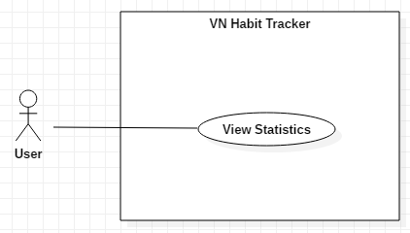

Figure 26 - <User> View Statistics

**Use Case Specification**

|  |  |  |  |
| --- | --- | --- | --- |
| **USE CASE – UC_22** | | | |
| **Use Case No.** | 22 | **Use Case Version** | 1.0 |
| **Use Case Name** | View Statistics | | |
| **Author** | DatLT | | |
| **Date** | 13/11/2018 | **Priority** | Normal |
| **Actor:**   * User   **Summary:**   * This use case allows the user want to view all statistics of the habit.   **Group:**   * View all statistic of the habit.   **Triggers:**   * User click on statistic button.   **Preconditions:**   * Guest must login.   **Post Conditions:**   * **Success:** System shows list habits. * **Fail:** System not show list habits.   **Main Success Scenario:**   |  |  |  | | --- | --- | --- | | **Step** | **Actor Action** | **System Response** | | 1 | User click on statistic button. | - Display information in chart about all habits follow week, month and year:   * Tổng số thói quen: text. * Tổng số lượt hoàn thành: text. * Chart habit. |   **Relationships:**  N/A.  **Business Rules:**   * The information is loaded from the system. * User views statistic all of the habit follow week, month, year. * After view statistics. The user will return to the main page. | | | |

Table 34 - <User> View Statistics

##### <User> View Top Habits

**Use Case Diagram**

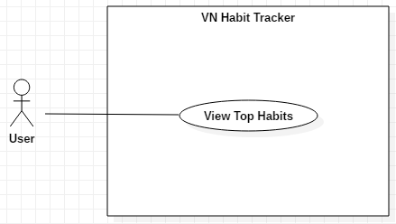

Figure 27 - <User> View Top Habits

**Use Case Specification**

|  |  |  |  |
| --- | --- | --- | --- |
| **USE CASE – UC_23** | | | |
| **Use Case No.** | 23 | **Use Case Version** | 1.0 |
| **Use Case Name** | View Top Habits | | |
| **Author** | DatLT | | |
| **Date** | 13/11/2018 | **Priority** | Normal |
| **Actor:**   * User   **Summary:**   * This use case allows the users view habits that most user community.   **Group:**   * View top habits from community.   **Triggers:**   * User click on top habit button.   **Preconditions:**   * Guest must login.   **Post Conditions:**   * **Success:** System shows list top habits. * **Fail:** System not shows list top habits.   **Main Success Scenario:**   |  |  |  | | --- | --- | --- | | **Step** | **Actor Action** | **System Response** | | 1 | User click on top habits button. | The system request information in list habits that community use most. |   **Relationships:**  N/A  **Business Rules:**   * User view habits that most user community. * The system suggested for user that habits are most use. | | | |

Table 35 - <User> View Top Habits

##### <User> Logout

**Use Case Diagram**

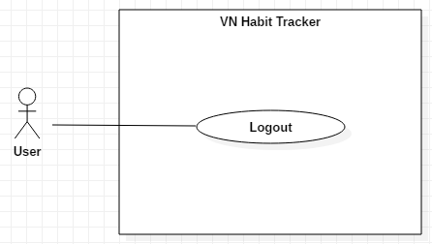

Figure 28 - <User> Logout

**Use Case Specification**

|  |  |  |  |
| --- | --- | --- | --- |
| **USE CASE – UC_25** | | | |
| **Use Case No.** | 25 | **Use Case Version** | 1.0 |
| **Use Case Name** | Logout | | |
| **Author** | ThangNH | | |
| **Date** | 14/11/2018 | **Priority** | Normal |
| **Actor:**   * User   **Summary:**   * This use case allows the user want to logout from application.   **Goal:**   * User logout the system.   **Triggers:**   * User clicks Settings button. * User clicks “Đăng xuất” button.   **Preconditions:**   * Guest login success.   **Post Conditions:**   * **Success:** System shows success message. * **Fail:** System shows error message.   **Main Success Scenario:**   |  |  |  | | --- | --- | --- | | **Step** | **Actor Action** | **System Response** | | 1 | User clicks “Đăng xuất” button. | System shows “Bạn muốn đăng xuất?” message. | | 2 | User clicks “Đồng ý” button. | - User will logout the system.  [Exception 1] |   **Alternative:** N/A.  **Exception:**   |  |  |  | | --- | --- | --- | | **No** | **Actor Action** | **System Response** | | 1 | User click “Hủy bỏ” button. | Closed this form. |   **Relationships:**  N/A.  **Business Rules:**   * After logout from the system, system will return login page. * User login with another account. | | | |

Table 36 - <User> Logout

* + - 1. <Admin> Overview Use Case

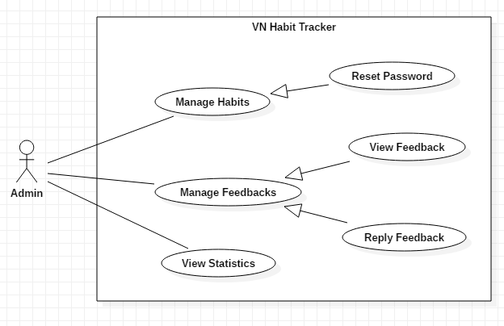

Figure 29 - <Admin> Overview Use Case

##### <Admin> Reset Password

**Use Case Diagram**

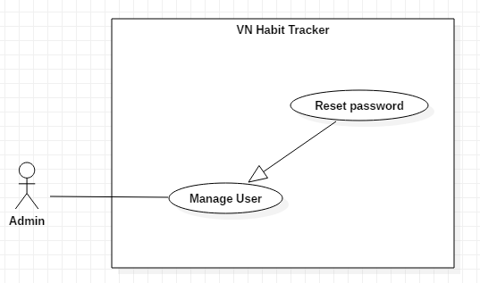

Figure 30 - <Admin> Reset Password

**Use Case Specification**

|  |  |  |  |
| --- | --- | --- | --- |
| **USE CASE – UC_25** | | | |
| **Use Case No.** | 25 | **Use Case Version** | 1.0 |
| **Use Case Name** | Reset Password | | |
| **Author** | TungPT | | |
| **Date** | 15/11/2018 | **Priority** | Normal |
| **Actor:**   * Admin   **Summary:**   * This use case allows the admin to reset password.   **Goal:**   * Reset password.   **Triggers:**   * Admin click on “quản lý người dùng” button. * Admin accept request of user. * Admin click on “tạo lại mật khẩu” button.   **Preconditions:**   * Admin must login. * User must send request.   **Post Conditions:**   * **Success:** System shows “Tạo mới mật khẩu thành công.” message. * **Fail:** System shows “Tạo mới mật khẩu thất bại” message.   **Main Success Scenario:**   |  |  |  | | --- | --- | --- | | **Step** | **Actor Action** | **System Response** | | 1 | Admin accept request of user to reset password. | The system shows “Đã chấp nhận yêu cầu” message. | | 2 | Admin click on “Tạo mới mật khẩu” button. | The system shows all list user use applications. | | 3 | Admin click into a user. | - The system sent a link to the user to change password.  [Exception 1] |   **Alternative:** N/A.  **Exceptions:**   |  |  |  | | --- | --- | --- | | **No** | **Cause** | **System Response** | | 1 | Network. | Shows “mất kết nối! Xin thử lại” message. |   **Relationships:**  N/A  **Business Rules:**   * After reset password of a user. The admin will return to the main page. * User can take password by email. | | | |

Table 37 - <Admin> Reset Password

##### <Admin> View Feedback

**Use Case Diagram**

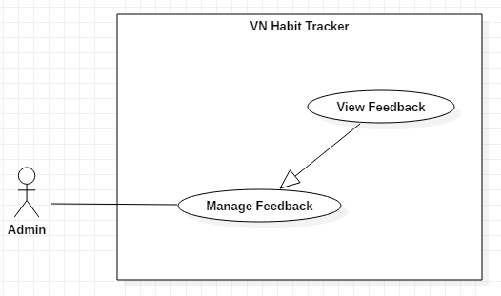

Figure 31 - <Admin> View Feedback

**Use Case Specification**

|  |  |  |  |
| --- | --- | --- | --- |
| **USE CASE – UC_26** | | | |
| **Use Case No.** | 26 | **Use Case Version** | 1.0 |
| **Use Case Name** | View Feedback | | |
| **Author** | TungPT | | |
| **Date** | 15/11/2018 | **Priority** | Normal |
| **Actor:**   * Admin   **Summary:**   * This use case allows the admin to view all feedback of users.   **Group:**   * View feedback of users.   **Triggers:**   * Admin click on “quản lý phản hồi” button.   **Preconditions:**   * Admin must login. * User sent feedback.   **Post Conditions:**   * **Success:** System shows message. * **Fail:** System shows message.   **Main Success Scenario:**   |  |  |  | | --- | --- | --- | | **Step** | **Actor Action** | **System Response** | | 1 | Admin click on “quản lý phản hồi” button. | The system shows all feedback of users. | | 2 | Admin clicks into a feedback. | - The system shows content of this feedback.  [Exception 1] |   **Alternative:** N/A.  **Exceptions:**   |  |  |  | | --- | --- | --- | | **No** | **Cause** | **System Response** | | 1 | Network. | Shows “mất kết nối! Xin thử lại” message. | | 2 | User click on “Đóng” icon. | - Close list of feedbacks. |   **Relationships:**  N/A  **Business Rules:**   * After view feedback of user. The admin will return to the main page. * The feedback of user is private and only admin is seen. | | | |

Table 38 - <Admin> View Feedback

##### <Admin> Reply Feedback

**Use Case Diagram**

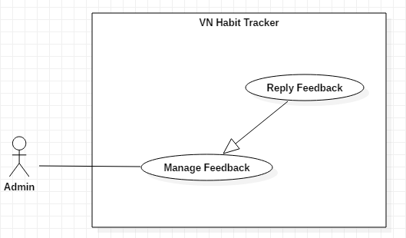

Figure 32 - <Admin> Reply Feedback

**Use Case Specification**

|  |  |  |  |
| --- | --- | --- | --- |
| **USE CASE – UC_27** | | | |
| **Use Case No.** | 27 | **Use Case Version** | 1.0 |
| **Use Case Name** | Reply feedback. | | |
| **Author** | TungPT | | |
| **Date** | 07/10/2018 | **Priority** | Normal |
| **Actor:**   * Admin   **Summary:**   * This use case allows the admin to reply feedback if user sent feedback.   **Group:**   * Admin reply feedback when user feedback about this application.   **Triggers:**   * Admin click on “quản lý phản hồi” button. * Admin accepts feedback of users. * Admin click on “trả lời yêu cầu” button   **Preconditions:**   * Admin must login. * User must sent feedback.   **Post Conditions:**   * **Success:** System shows message. * **Fail:** System shows message.   **Main Success Scenario:**   |  |  |  | | --- | --- | --- | | **Step** | **Actor Action** | **System Response** | | 1 | Admin click “quản lý phản hồi” button. | The system shows all feedback of users. | | 2 | Admin clicks on another user. | The system shows detail of this feedback. | | 3 | Admin click “trả lời” button.  [Alternatives 1] | - The system shows text box to admin reply feedback  [Exception 1] |   **Alternative:** N/A.  **Exceptions:**   |  |  |  | | --- | --- | --- | | **No** | **Cause** | **System Response** | | 1 | Network. | Shows “mất kết nối! Xin thử lại” message. | | 2 | User click on “Đóng” icon. | - Closed this feedback. |   **Relationships:**  N/A  **Business Rules:**   * After reply password of a user. The admin will return to the main page. | | | |

Table 39 - <Admin> Reply Feedback

##### <Admin> View Statistics

**Use Case Diagram**

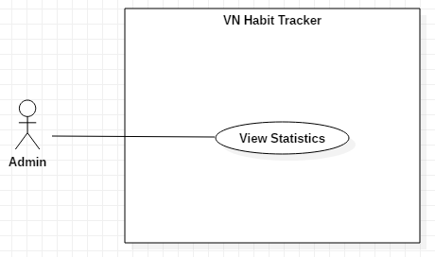

Figure 33 - <Admin> View Statistics

**Use Case Specification**

|  |  |  |  |
| --- | --- | --- | --- |
| **USE CASE – UC_28** | | | |
| **Use Case No.** | 28 | **Use Case Version** | 1.0 |
| **Use Case Name** | View Statistics | | |
| **Author** | TungPT | | |
| **Date** | 15/11/2018 | **Priority** | Normal |
| **Actor:**   * Admin   **Summary:**   * This use case allows the Admin view statistic detail of user’s habits.   **Goal:**   * View statistics detail of user’s habits.   **Triggers:**   * Admin clicks on “Thống kê theo người dùng” button.   **Preconditions:**   * Admin login with role admin.   **Post Conditions:**   * **Success:** Statistic detail have been displayed. * **Fail:** Statistic detail haven’t been displayed.   **Main Success Scenario:**   |  |  |  | | --- | --- | --- | | **Step** | **Actor Action** | **System Response** | | 1 | User click on “Thống kê theo người dùng” button. | System shows statistics detail of user’s habits.  + View by week.  + View by month.  + View by year. | | 2 | User click on “Tuần” button. | - The system will show the information of the habit belong to week.  [Exception 1, 2] | | 3 | User click on “Tháng” button. | - The system shows the information of the habit belong to month.  [Exception 1, 2] | | 4 | User click on “Năm” button. | - The system shows the information of the habit belong to year.  [Exception 1, 2] |   **Alternative:** N/A.  **Exceptions:**   |  |  |  | | --- | --- | --- | | **No** | **Cause** | **System Response** | | 1 | User click on Close icon. | Closed this page. | | 2 | Network. | System shows “Lỗi không thể kết nối!” message. |   **Relationships:**  N/A  **Business Rules:**   * After view statistic of user’s habits successfully. The admin will return to the main page. * Admin can view all user’s habits. | | | |

Table 40 - <Admin> View Statistics

1. Software System Attribute

### Usability

* Provide a convenient way to interact with system.
* Screen layout and navigation are clear and easy to use.
* Interface are simple and clear, user can easy to manage habit.
* The system usability is easy to use that needs less than 2 days of training for company staffs to use the system.

### Reliability

* System notification success rate is less than 2 failed notifications per 1000 sent.

### Availability

* User connects to internet to login into the application.
* User uses offline after login and connect internet to push data to the server.
* The system updates every day at 00:01 am.

### Security

* Private: Each role of user has a specific permission to interact with the system.
* Only admin can manage user and feedback of user.
* All input data are validated before saving to database.

### Maintainability

* The code is easy to maintain and upgrade.
* Maintain the whole system every 1 months.
* Accidental problem is resolved within acceptable time.

### Portability

* The website is running on Windows 7 or above.
* The mobile application running on a device with API 23 or above.

### Performance

* All requests are handled in maximum time of 5 seconds.

1. Conceptual Diagram

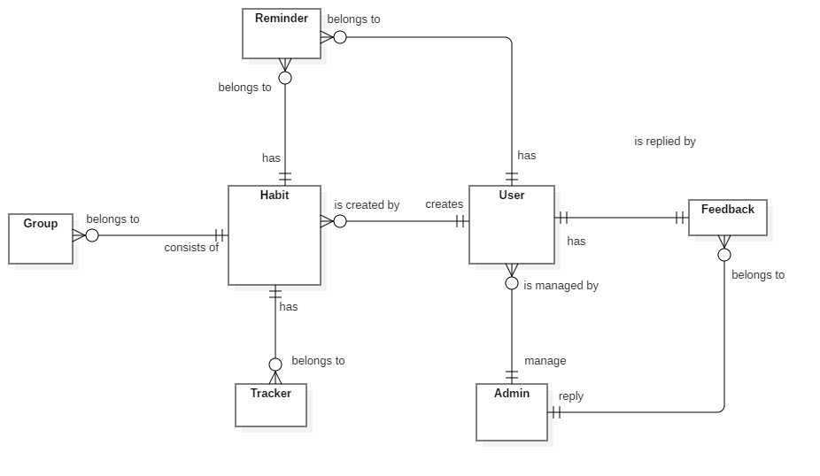

Figure 34 - Conceptual Diagram

***Data Dictionary***

|  |  |
| --- | --- |
| **Entity Data dictionary: describe all content of all entities** | |
| **Entity Name** | **Description** |
| User | Contain the user information. |
| Admin | Contain the admin information. |
| Feedback | Contain the feedback information. |
| Habit | Contain the habit information. |
| Notification | Contain the notification information. |
| Tracking | Contain the vehicle information. |
| Reminder | Contain the reminder information. |
| Group | Contain the group information. |

Table 41 - Conceptual Diagram Dictionary

1. Software Design Description
2. Design Overview

- This document describes the technical and user interface design of MSSC System. It includes the architectural design, the detailed design of common functions and business functions and the design of database model.

- The architectural design describes the overall architecture of the system and the architecture of each main component and subsystem.

- The detailed design describes static and dynamic structure for each component and functions. It includes class diagrams, class explanations and sequence diagrams for each use cases.

- The database design describes the relationships between entities and details of each entity. - Document overview:

* + Section 2: gives an overall description of the system architecture design.
  + Section 3: gives component diagrams that describe the connection and integration of the system.
  + Section 4: gives the detail design description which includes class diagram, class explanation, and sequence diagram to details the application functions.
  + Section 5: describe screens design.
  + Section 6: describe a fully attributed ERD.
  + Section 7: describe algorithms.

1. System architecture design


5. * 1. Web application architecture description

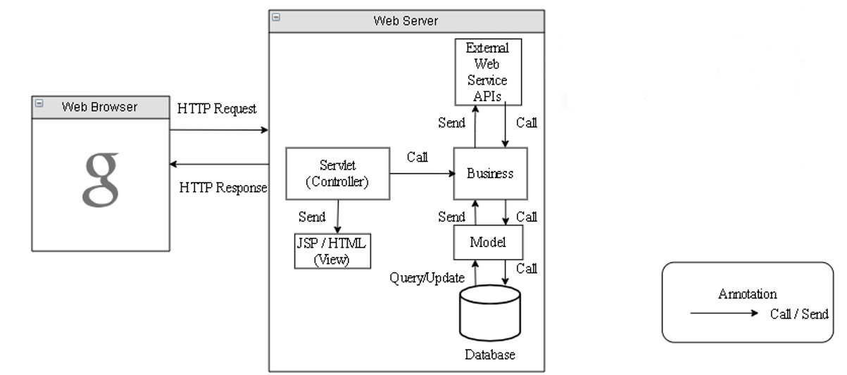

Figure 35 - Web application architecture description

In Web Application, the system is developed under J2EE MVC architecture style. We choose this architecture for Web application because of in scope of the 4 - member team, MVC architecture makes it easier to split the big project into small modules and make it easier to assign each module for members in our team.

This project follows MVC architecture with following components:

* **Servlet (Controller)** is the parts of the application that acts like event handler to handle user interaction. Typically, the controller reads data from a request and calls appropriate Business’s method, then selects view to return to user.
* **JSP/HTML (View)** is the parts of the application that handles the display of the data. The selection of View is under control of Controller.
* **Business** is the parts of the application that do business processing to solve domain problems.
* **Model** is the parts of the application that acts like a data transfer object between the system and database.
* **Web Service** is the parts of the application that acts like an event handler for web and mobile communication via REST method.
  + 1. Mobile application architecture description

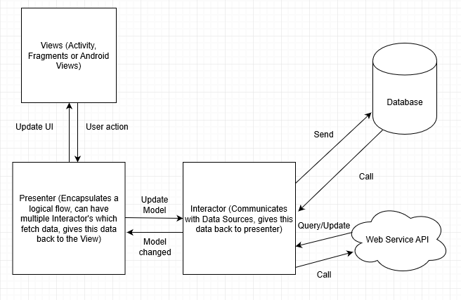

Figure 36 - Mobile application architecture description

Numerous architectural patterns appeared, but MVP (Model View Presenter) can fulfill the complete requirements of Android developers.

MVP is one of the patterns, which Android community prefers at this time.

In Android, the application should be easily extensible and maintainable. Therefore, in order to maintain the level, it is important to define separated layers well. And, MVP makes things easier for developers and it makes the views independent of the data source.

* **The Model**
* It represents the layer, which holds the business logic as well as controls how data is created, stored and modified. In Android, it is a data access layer, for example, database API or Remote server API.
* The Model consists of components that are responsible for functionalities like for generating, storing, exposing and fetching the data.
* All these functionalities usually perform in the background thread. Because, these functionalities could be time-consuming, and they can potentially block the main thread UI.
* **The View**
* It is a passive interface, which displays data, and the routes user actions to Presenter.
* In Android, the View is represented by Activity, Fragment or View.
* The View component contains a visual part of the application.
* The View contains the UI and it does not contain any logic or knowledge of the displayed data.
* **The Presenter**
* The Presenter is in between Model and the View. And, it triggers the business logic, and lets to know ‘the View’ when to update.
* It recovers data received from the Model and shows it in the View.
* It interacts with the Model, then fetches and transforms the data from the Model to update the view.

1. Component Diagram

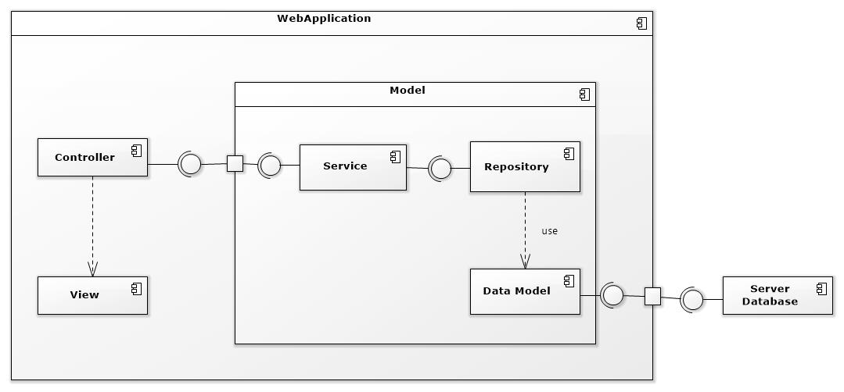

Figure 37 - Component Web Diagram

| **Components Dictionary: Describes components** | |
| --- | --- |
| Web Apllicaiton | Component to controll the system and process request from mobile. Contains sub component: Model, Web Service, Controller. |
| View | Component that display data. |
| Controller | Component of website to handle request from web. |
| Service | Component to handle business logic of Website component. |
| Repository | Component that communicate with database. |
| Data Model | Component that do the interaction between the system and database. Contain sub components: Repository and Service. |
| Server Database | Component that store data of system. |

Table 42 - Component Web Dictionary

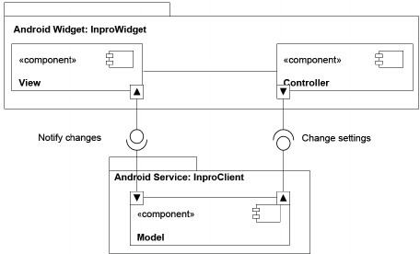

Figure 38 - Component Android Application Diagram

| **Components Dictionary: Describes components** | |
| --- | --- |
| Android Apllicaiton | Component to controll the system and process request from mobile. Contains sub component: Model, Android Service, Controller. |
| View | Component that display data. |
| Controller | Component of application to handle request from application. |
| Android Service | Component to handle business logic of application component. |
| Model | Component that do the interaction between the system and database. Contain sub components: Repository and Service. |

Table 43 - Component Android Application Dictionary

1. Detailed Description
   * 1. Class diagram

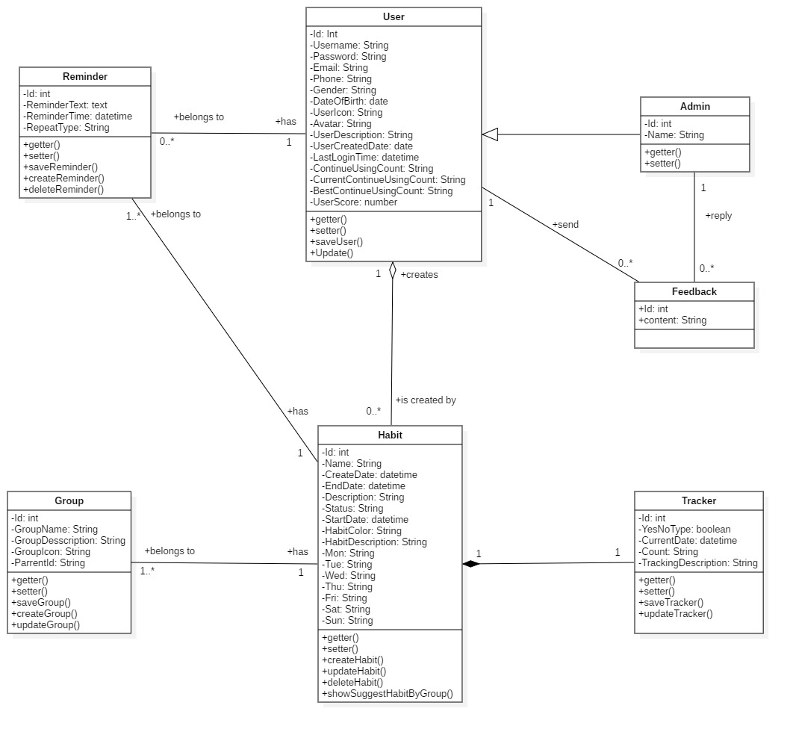

Figure 39 - Class Diagram

|  |  |  |
| --- | --- | --- |
| **CLASS DICTIONARY: DESCRIBE CLASS** | | |
| **Class Name** | **Mapping column with Conceptual diagram** | **Description** |
| **Admin** | Admin | Contains the admin information |
| **User** | User | Contains the user information |
| **Habit** | Habit | Contains the habit information |
| **Reminder** | reminder | Contain the reminder information |
| **Feedback** | Feedback | Contains the feedback information |
| **Tracking** | Tracking | Contains the Tracking information |

Table 44 - Class Diagram Dictionary

* + 1. Class Diagram Explanation
       1. User

|  |  |  |  |
| --- | --- | --- | --- |
| Attribute | Type | Visibility | Description |
| id | Integer | Private | Unique identifier of a user |
| username | String | Private | User’s username |
| password | String | Private | User’s password |
| fullName | String | Private | User’s full name |
| phone | String | Private | User’s phone |
| email | String | Private | User’s email |
| roleId | Integer | Private | Id of user’s role |
| isActive | Boolean | Private | User’s status |
| Method | **Return Type** | **Visibility** | **Description** |
| getter | Attribute type | Public | Get value of attribute |
| setter | Void | Public | Set value for attribute |

Table 46 - User

* + - 1. Admin

|  |  |  |  |
| --- | --- | --- | --- |
| Attribute | Type | Visibility | Description |
| id | Integer | Private | Unique identifier of a admin |
| username | String | Private | Admin’s username |
| name | String | Private | Admin’s name |
| password | String | Private | Admin’s password |
| fullName | String | Private | Admin’s full name |
| phone | String | Private | Admin’s phone |
| email | String | Private | Admin’s email |
| roleId | Integer | Private | Id of admin’s role |
| isActive | Boolean | Private | Admin’s status |
| Method | **Return Type** | **Visibility** | **Description** |
| getter | Attribute type | Public | Get value of attribute |
| setter | Void | Public | Set value for attribute |

Table 47 - Admin

* + - 1. Habit

|  |  |  |  |
| --- | --- | --- | --- |
| Attribute | Type | Visibility | Description |
| id | Integer | Private | Unique identifier of a habit |
| name | String | Private | Habit’s name |
| createDate | datetime | Private | Habit’s create date |
| endDate | datetime | Private | Habit’s end date |
| startDate | datetime | Private | Habit’s start date |
| finishDate | datetime | Private | Habit’s finish date |
| group | String | Private | Habit’s group |
| description | String | Private | Habit’s description |
| status | String | Private | Habit’s status |
| Method | **Return Type** | **Visibility** | **Description** |
| getter | Attribute type | Public | Get value of attribute |
| setter | Void | Public | Set value for attribute |
| getHabitList | List | Public | Get all habit of user |

Table 48 - Habit

* + - 1. Feedback

|  |  |  |  |
| --- | --- | --- | --- |
| Attribute | Type | Visibility | Description |
| id | Integer | Private | Unique identifier of user |
| content | String | Private | Feedback’s content |
| Method | **Return Type** | **Visibility** | **Description** |

Table 49 - Feedback

* + - 1. Reminder

|  |  |  |  |
| --- | --- | --- | --- |
| Attribute | Type | Visibility | Description |
| id | Integer | Private | Unique identifier of the habit |
| notificationName | String | Private | Notification’s notification name |
| time | Datetime | Private | Notification’s time |
| description | String | Private | Notification’s description |
| Method | **Return Type** | **Visibility** | **Description** |
| getter | Attribute type | Public | Get value of attribute |
| setter | Void | Public | Set value for attribute |

Table 50 – Reminder

* + - 1. Tracking

|  |  |  |  |
| --- | --- | --- | --- |
| Attribute | Type | Visibility | Description |
| id | Integer | Private | Unique identifier of a habit |
| type | Boolean | Private | Tracking’s type |
| thisDay | datetime | Private | Tracking’s this day |
| Method | **Return Type** | **Visibility** | **Description** |
| getter | Attribute type | Public | Get value of attribute |
| setter | Void | Public | Set value for attribute |

Table 51 – Tracking

* + 1. Interaction Diagram
       1. Add habit

*Summary: this diagram show process of user adds habit*

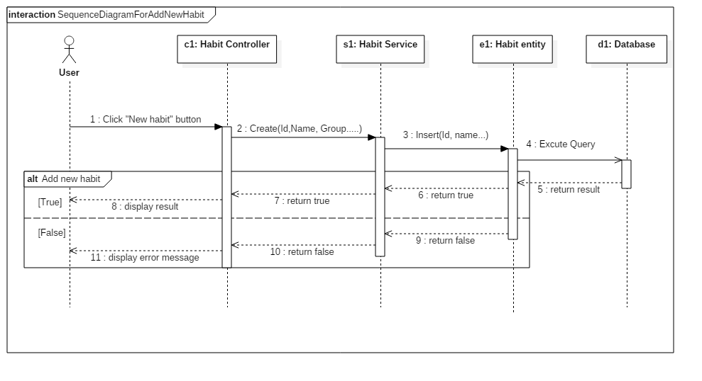

Figure 40 - Sequence Diagram for add habit <User>

* + - 1. Edit Habit

*Summary: this diagram show process of user edits a habit.*

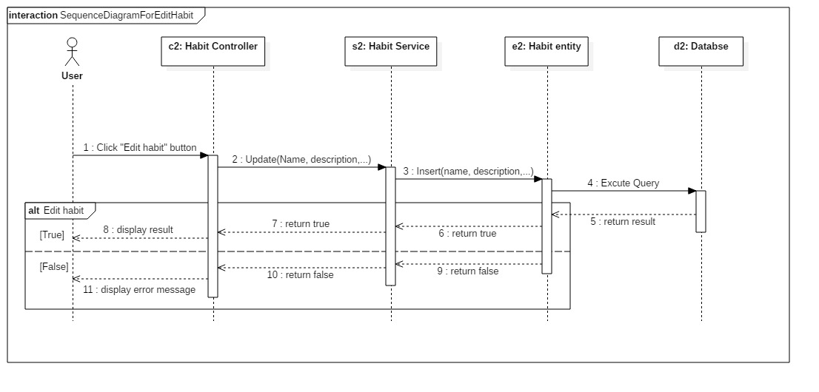

Figure 41 -Sequence Diagram for edit habit <User>

* + - 1. Delete Habit

*Summary: this diagram show process of user deletes a habit*

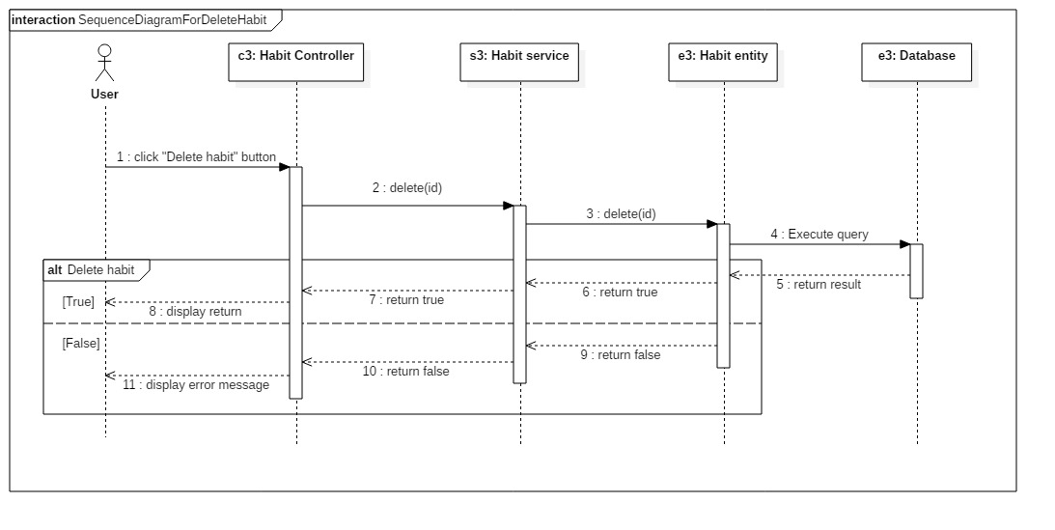

Figure 42 - Sequence Diagram for delete habit <User>

* + 1. Activity diagram

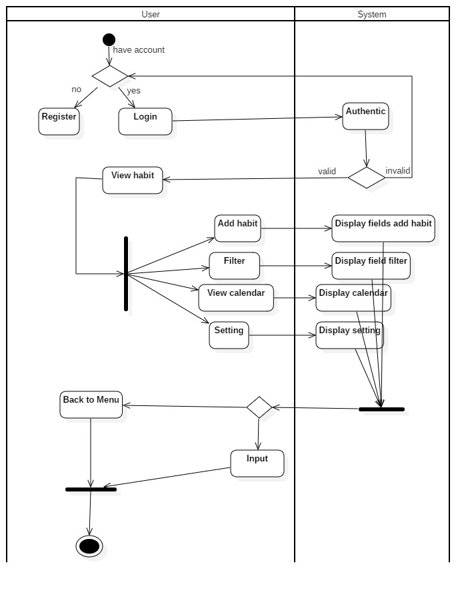

Figure 43 - Activity Diagram for habit

1. User Interface Design
   * 1. Mobile application user interface
     2. Login

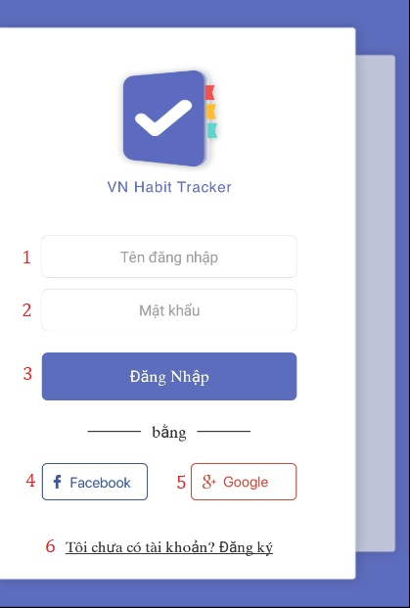

**Field**

|  |  |  |  |  |  |  |  |
| --- | --- | --- | --- | --- | --- | --- | --- |
| **No** | **Field Name** | **Description** | **Read only** | **Mandatory** | **Control Type** | **Data Type** | **Length** |
| 1 | Username | Username to login | No | Yes | Textbox | String |  |
| 2 | Password | Password to login | No | Yes | Textbox | String |  |

**Buttons/Hyperlinks:**

|  |  |  |  |  |
| --- | --- | --- | --- | --- |
| **No** | **Function** | **Description** | **Validation** | **Outcome** |
| 3 | Login | Login into system | Validate all required fields | Navigate to page |
| 4 | Login with facebook | Login into system | Validate all required fields | Navigate to page |
| 5 | Login with google | Login into system | Validate all required fields | Navigate to page |
| 6 | Register | Creates account |  | Register page |

* + 1. Register

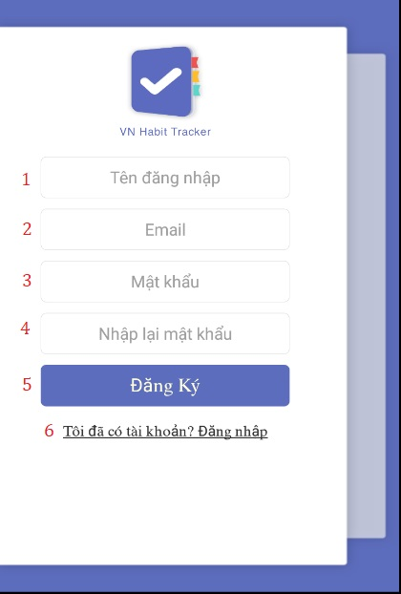

**Field**

|  |  |  |  |  |  |  |  |
| --- | --- | --- | --- | --- | --- | --- | --- |
| **No** | **Field Name** | **Description** | **Read only** | **Mandatory** | **Control Type** | **Data Type** | **Length** |
| 1 | Username | Username to register | No | Yes | Textbox | String |  |
| 2 | Email | Email to register | No | Yes | Textbox | String |  |
| 3 | Password | Password to register | No | Yes | Textbox | String |  |
| 4 | Re-enter password | Input password again | No | Yes | Textbox | String |  |

**Buttons/Hyperlinks:**

|  |  |  |  |  |
| --- | --- | --- | --- | --- |
| **No** | **Function** | **Description** | **Validation** | **Outcome** |
| 5 | Register | Create an account | Validate all required fields | Navigate to page |
| 6 | Login with an account | Login into system |  | Login page |

* + 1. Main Page

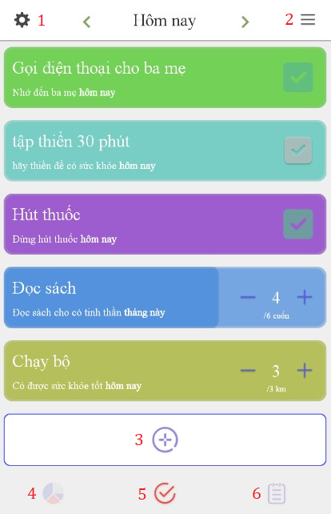

**Buttons/Hyperlinks:**

|  |  |  |  |  |
| --- | --- | --- | --- | --- |
| **No** | **Function** | **Description** | **Validation** | **Outcome** |
| 1 | Settings | Settings of user | N/A | Settings page |
| 2 | Filter | Arrange habits by type | N/A | Filter page |
| 3 | Add a habit | Create new build or quit a habit | N/A | Add habit page |
| 4 | Statitis | Show statitis | N/A | Statitis page |
| 5 | Schedule |  | N/A |  |
| 6 | List habit | Show all habit | N/A | Main menu page |

1. Database Design
   * 1. Entity relationship diagram (ERD)

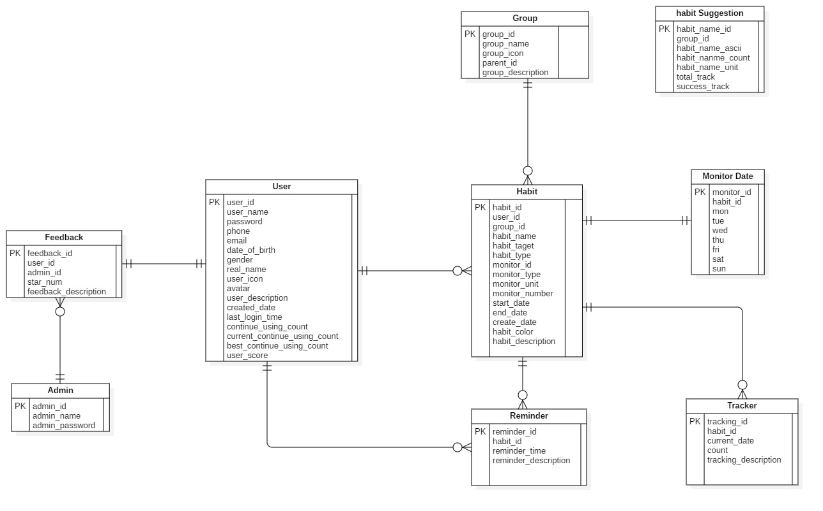

* + 1. Entity dictionary

|  |  |
| --- | --- |
| **Entity Data Dictionary: describe content of all entities** | |
| **Entity name** | **Description** |
| User | Contains the user’s information. |
| Admin | Contains the admin’s information. |
| Habit | Contains the habit’s information. |
| Reminder | Contains the reminder’s information. |
| Group | Contains the group’s information. |
| Tracking | Contains the tracking’s information. |
| Feedback | Contains the feedback’s information. |
| Monitor Date | Contains the monitor date’s information. |
| About | Contains the about’s information. |
| Habit Suggestion | Contains the habit suggestion’s information. |

|  |  |  |  |  |
| --- | --- | --- | --- | --- |
| Table Name | Attributes | Description | Domain | Nulls |
| User | User_id | ID of user | varchar(36) | No |
| username | Username of user | varchar(10) | No |
| password | Password of user | text | No |
| email | Email of user | text | Yes |
| phone | Phone of user | text | Yes |
| date_of_birth | Date of birth of user | date | Yes |
| gender | Gender of user | tinyint(1) | Yes |
| real_name | real name of user | text | Yes |
| avatar | Avatar of user | text | Yes |
| user_description | Description of user | text | Yes |
| created_date | Date of user to register success. | date | Yes |
| last_login_time | Last time to login of user | date | Yes |
| continue_using_count | Application use chain | int(11) | Yes |
| current_continue_using_count | current application use chain | int(11) | Yes |
| best_continue_using_count | best application use chain | int(11) | Yes |
| user_score | Score of user | int(11) | Yes |
| Admin | admin_id | ID of admin | varchar(36) | No |
| admin_name | Username of admin | varchar(10) | No |
| admin_password | Passsword of admin | text | No |
| Habit | habit_id | ID of habit | varchar(36) | No |
| user_id | ID of user | varchar(36) | No |
| group_id | ID of group | varchar(36) | Yes |
| monitor_id | ID of monitor | varchar(36) | No |
| habit_name | Name of habit | text | No |
| habit_target | Target of habit | tinyint(1) | Yes |
| habit_type | Type of habit | tinyint(1) | Yes |
| monitor_type | Type of monitor | tinyint(1) | Yes |
| monitor_unit | Unit of monitor | text | Yes |
| monitor_number | Number of monitor | int(11) | Yes |
| start_date | Start date of habit | date | Yes |
| end_date | End date of habit | date | Yes |
| created_date | Created date of habit | date | Yes |
| habit_color | Color of habit | text | Yes |
| habit_description | Description of habit | text | Yes |
| habit_name_id | ID of habit | varchar(36) | No |
| Group | Group_id | ID of group | varchar(36) | No |
| Group_name | Name of group | text | No |
| Monitor date | monitor_id | ID of monitor | varchar(36) | No |
| habit_id | ID of habit | varchar(36) | No |
| mon | Monday | tinyint(1) | Yes |
| tue | Tueday | tinyint(1) | Yes |
| wed | Wednesday | tinyint(1) | Yes |
| thu | Thurday | tinyint(1) | Yes |
| fri | Friday | tinyint(1) | Yes |
| sat | saturday | tinyint(1) | Yes |
| sun | sunday | tinyint(1) | Yes |
| Reminder | reminder_id | ID of reminder | varchar(36) | No |
| habit_id | ID of habit | varchar(36) | No |
| reminder_time | Set time reminder | text | Yes |
| reminder_description | Description of reminder | text | Yes |
| Tracker | tracking_id | ID of tracking | varchar(36) | No |
| habit_id | ID of habit | varchar(36) | No |
| current_date | Current date | date | Yes |
| count | count tracking times | int(11) | Yes |
| tracking_description | Description of tracking | text | Yes |
| Habit suggestion | group_id | Group of habit | varchar(36) | Yes |
| habit_name_uni | Save values uni of habit | text | No |
| habit_name_ascii | Save values ascii of habit | text | No |
| habit_name_count | Number of times tracking habits | int(11) | Yes |
| total_track | Toal tracking habits | int(11) | Yes |
| success_track | Success tracking habits | int(11) | Yes |
| Feedback | Feedback_id | ID of feedback | varchar(36) | No |
| User_id | ID of user | varchar(36) | No |
| Admin_id | ID of admin | varchar(36) | No |
| Star_num | Application reviews | int(11) | Yes |
| Feedback_description | Description of feedback | text | No |

1. Algorithms
   * 1. Recommend the best habits for users by linear programming algorithm
        1. Definition

This algorithm is intended to suggest habits that are commonly used by the community and that are comparable to the current user.

* + - 1. Define problem

Helps newcomers or those who have long participated in good habits or give up bad habits to improve themselves.

* + - 1. Solution

Based on a user criteria, we have the following general formula:

|  |
| --- |
|  |

With:  
t: is the same display characters are sorted in decreasing turn by user.

d: is the difficulty of the habit.

c: is level of users.

Based on user criteria, we have the following level of user-formula:

Supposed:

Supposed:

c1: is level 1 – 3**.**

c2: is level 4 – 6.

c3: is level 7 – 10.

With c1, c2, c3 are specified by accumulated points

Accumulated points are calculated by:

For every time a habit is completed**:**

Daily habit**:** +1 score

Weekly habit: +3 score

Monthly habit**:** +12 score

Yearly habit**:** +150 score

* Points are only added at the end of the day / week / month / year

Habit chain**:**

0 – 7 days: +2 score

7 – 30 days: +4 score

30 – 60 days: +8 score

60 – 180 days: +16 score

>180 days: + 32 score

Next level are specified by: current level * 2 + level before of current level

Lv1**:** 0 score

Lv2: 10 score

Lv3: 20 score

Lv4: 50 score

Lv5: 120 score

Lv6: 290 score

Lv7: 700 score

Lv8: 1690 score

Lv9: 4080 score

Lv10: 9850 score

Based on a habit, we have the following difficulty of the habit-formula:

We have:

a: is the number of successful tracking of the habit.

b: is the total tracking of the habit ( success or failure).

Supposed:

p: The habit is done successfully.

p = a / b with a / b >= 0.8

f: The habit is done unsuccessfully.

f = a / b with a / b < 0.8

Supposed:

h: is the difficulty of the habit.

k1: The habit is done successfully.

k2: The habit is done unsuccessfully.

d1: easy habit.

d2: medium habit.

d3: difficult habit.

We have:

Difficulty of the habit =

⬄

If

h >= 0.8 -> d1: easy habit.

0.5 < h < 0.8 -> d2: medium habit.

h < 0.5 -> d3: difficult habit.

Then we recommend for user as below:

For c1, the easy habit is suggested.

For c2, the medium habit is suggested.

For c3, the difficult habit is suggested.

x (n) is a widely used habit, ∀n ∈ N * (x1 most users, x2 many second ...).

Based on the difficulty of the habit-formula and level of user-formula we have the following formula:

If c1 applies:

If c2 applies:

If c3 applies:

* + - 1. Complexity

In total, the complexity of this algorithm is **O ().**

* + - 1. Example

For example, 10 users level 1 use a habit "gym":

* User1: Habit "Gym" has a daily type.

Start date: 10/10/2018.

Current day: 20/10/2018.

* Day of implementation is 10 days, of which 8 days is successfully completed, 2 days is failure.

a / b = 0.8 => successful implementation of the habit (Pass).

* User2: Habit “Gym” has a yes/no type.

Start date: 1/10/2018.

Current day: 15/10/2018.

The implementation date is 15 days, of which 9 days are yes, 6 days are no.

a / b = 0.6 => implementation of the failure habit (Fail).

Supposed:

|  |  |  |  |  |  |  |  |  |  |  |
| --- | --- | --- | --- | --- | --- | --- | --- | --- | --- | --- |
|  | User 1 | User 2 | User 3 | User 4 | User 5 | User 6 | User 7 | User 8 | User 9 | User 10 |
|  | Pass | Fail | Pass | Pass | Fail | Pass | Pass | Pass | Pass | Pass |
| Habit | gym | gym | gym | gym | gym | gym | gym | gym | gym | gym |

8: Pass

2: Fail

* h >= 0.8 -> easy habit.

Example user A has done 2 habits with a tracking number is 15 => applies d1.

Assume the following top habit.

|  |  |  |  |  |  |
| --- | --- | --- | --- | --- | --- |
|  | Habit 1 (top1) | Habit 2 (top2) | Habit 3 (top3) | Habit 4(top4) | Habit5(top5) |
| Uses | 553 | 500 | 465 | 326 | 254 |
| Difficulty of the habit | Difficult | Medium | Difficult | Easy | Difficult |

User A is offered Habit 4.

* + - 1. Flowchart

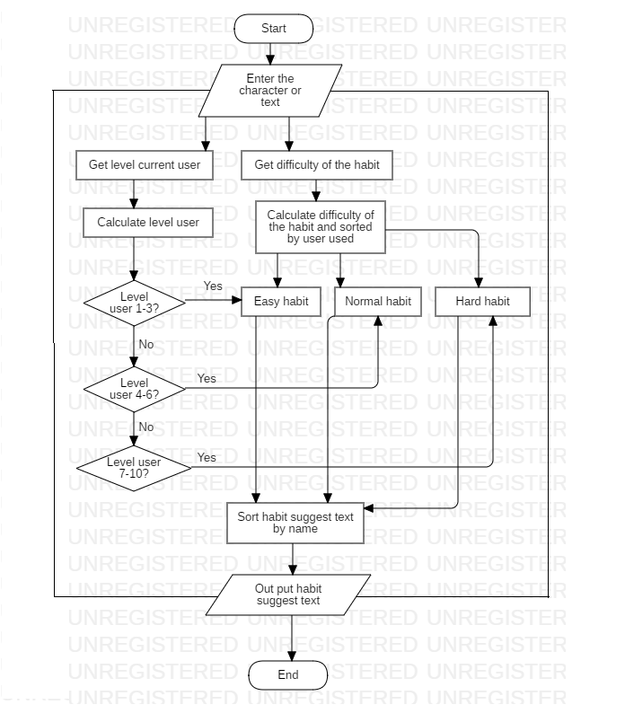

Figure 6- Flowchart of Recommend the best habits for users by linear programming algorithm

1. System Implementation & Test
2. Introduction
   * 1. Overview

This section describes the approach and methodologies used by group to plan, organize and manage the testing of VHT application. It provides in detail all necessary information about the implementation and testing procedure of the system included test plans, test cases, test result, test environments, pass/fail criteria and risks estimations as well as a checklist to cover all possible cases.

* + 1. Test approach
* Goal: Test all features in the whole VHT application based on the core flow.
* Method: black-box testing.
* Technique: check list.

The testing for this project consists of Integration System test level. Testing the program which was integrated and as a complete system to ensure that the software requirements have been met.

* Integration testing is performed by all member of team and approved by team leader.

System testing is focused on assessing the system’s reliability. This process is concerned with finding errors that result from unanticipated interactions between components and component interface problems.

2. Database Relationship Diagram
4. 2. 1. Physical diagram

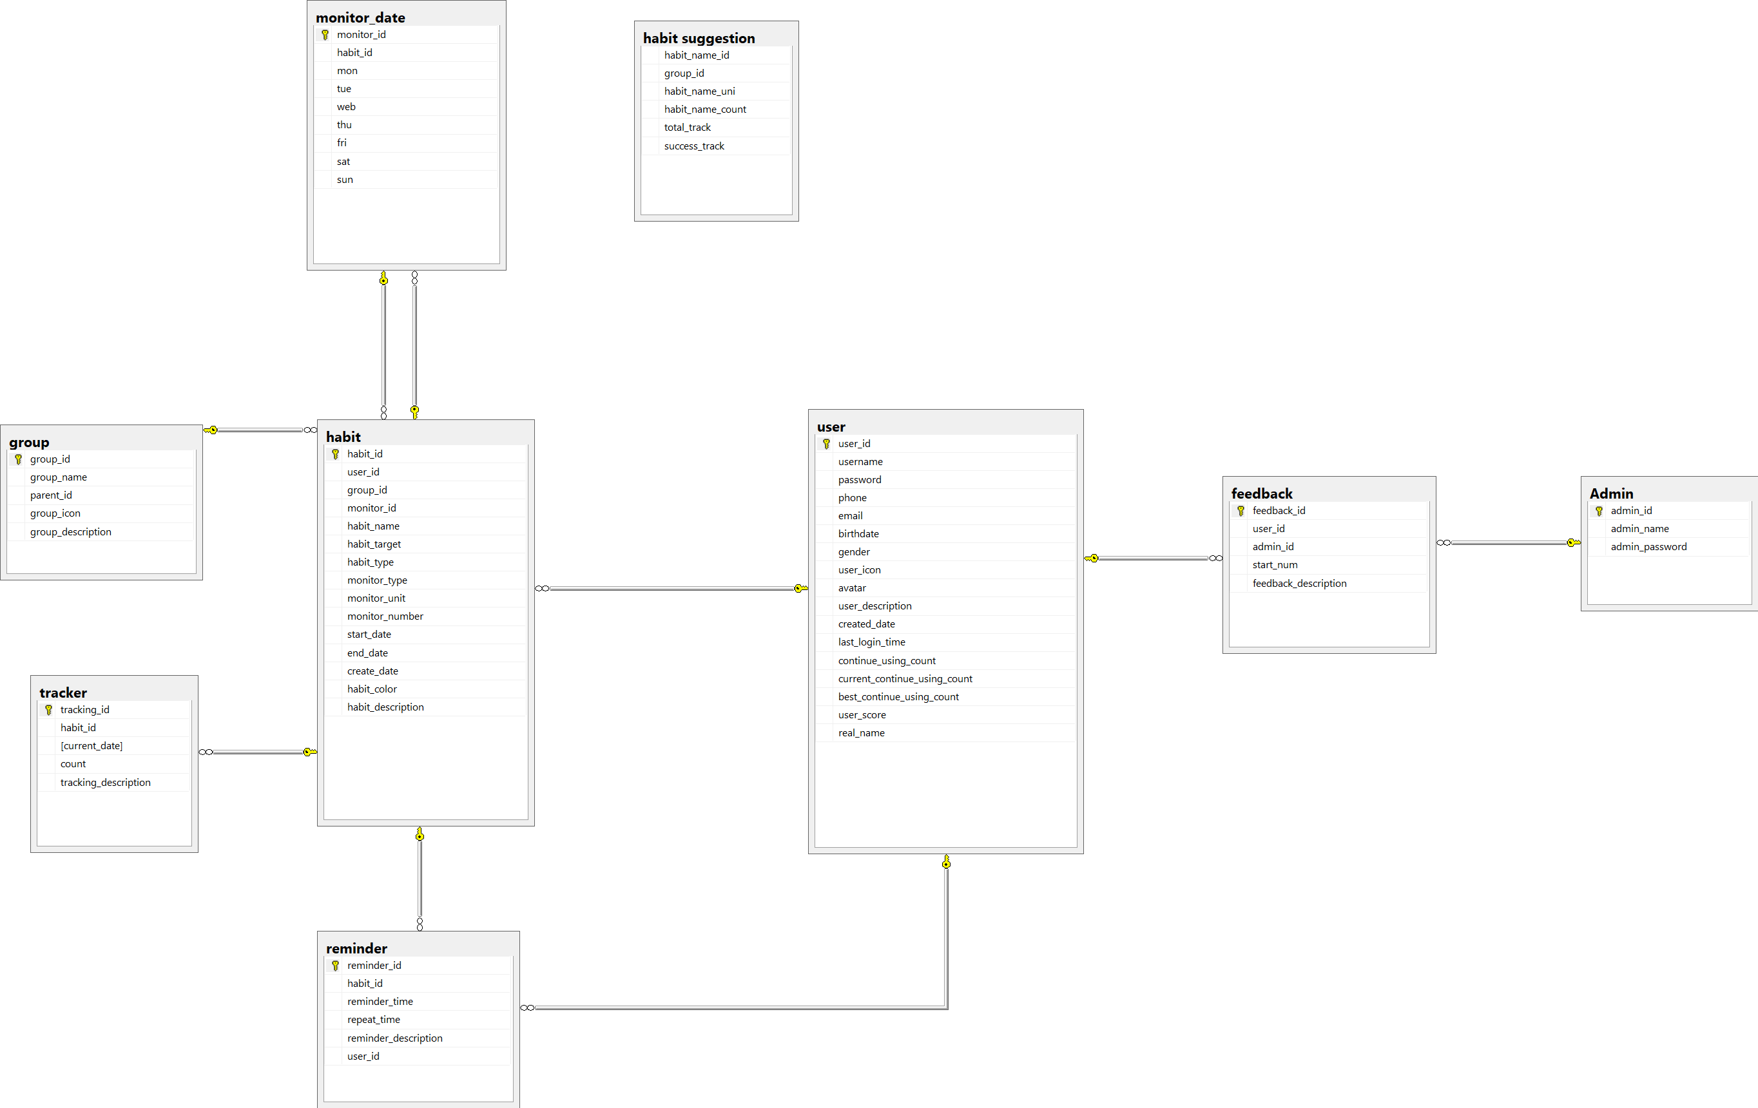

* + 1. Data dictionary

|  |  |
| --- | --- |
| DATA DICTIONARY: DESCRIBE CONTENT OF ALL TABLES | |
| Table name | **Description** |
| User | Contains the user information. |
| Admin | Contains the admin information. |
| Habit | Contains the habit information. |
| Feedback | Contains the feedback information. |
| Group | Contains the group information. |
| Monitor date | Contains the monitor date information. |
| Tracking | Contains the tracking information. |
| Reminder | Contains the reminder information. |
| Habit suggestion | Contains the habit suggestion information. |

Table 52 - physical diagram dictionary

|  |  |  |  |  |
| --- | --- | --- | --- | --- |
| Table Name | Attributes | Description | Domain | Nulls |
| User | User_id | ID of user | varchar(36) | No |
| username | Username of user | varchar(10) | No |
| password | Password of user | text | No |
| email | Email of user | text | Yes |
| phone | Phone of user | text | Yes |
| date_of_birth | Date of birth of user | date | Yes |
| gender | Gender of user | tinyint(1) | Yes |
| real_name | real name of user | text | Yes |
| avatar | Avatar of user | text | Yes |
| user_description | Description of user | text | Yes |
| created_date | Date of user to register success. | date | Yes |
| last_login_time | Last time to login of user | date | Yes |
| continue_using_count | Application use chain | int(11) | Yes |
| current_continue_using_count | current application use chain | int(11) | Yes |
| best_continue_using_count | best application use chain | int(11) | Yes |
| user_score | Score of user | int(11) | Yes |
| Admin | admin_id | ID of admin | varchar(36) | No |
| admin_name | Username of admin | varchar(10) | No |
| admin_password | Passsword of admin | text | No |
| Habit | habit_id | ID of habit | varchar(36) | No |
| user_id | ID of user | varchar(36) | No |
| group_id | ID of group | varchar(36) | Yes |
| monitor_id | ID of monitor | varchar(36) | No |
| habit_name | Name of habit | text | No |
| habit_target | Target of habit | tinyint(1) | Yes |
| habit_type | Type of habit | tinyint(1) | Yes |
| monitor_type | Type of monitor | tinyint(1) | Yes |
| monitor_unit | Unit of monitor | text | Yes |
| monitor_number | Number of monitor | int(11) | Yes |
| start_date | Start date of habit | date | Yes |
| end_date | End date of habit | date | Yes |
| created_date | Created date of habit | date | Yes |
| habit_color | Color of habit | text | Yes |
| habit_description | Description of habit | text | Yes |
| habit_name_id | ID of habit | varchar(36) | No |
| Group | Group_id | ID of group | varchar(36) | No |
| Group_name | Name of group | text | No |
| Monitor date | monitor_id | ID of monitor | varchar(36) | No |
| habit_id | ID of habit | varchar(36) | No |
| mon | Monday | tinyint(1) | Yes |
| tue | Tueday | tinyint(1) | Yes |
| wed | Wednesday | tinyint(1) | Yes |
| thu | Thurday | tinyint(1) | Yes |
| fri | Friday | tinyint(1) | Yes |
| sat | saturday | tinyint(1) | Yes |
| sun | sunday | tinyint(1) | Yes |
| Reminder | reminder_id | ID of reminder | varchar(36) | No |
| habit_id | ID of habit | varchar(36) | No |
| reminder_time | Set time reminder | text | Yes |
| reminder_description | Description of reminder | text | Yes |
| Tracker | tracking_id | ID of tracking | varchar(36) | No |
| habit_id | ID of habit | varchar(36) | No |
| current_date | Current date | date | Yes |
| count | count tracking times | int(11) | Yes |
| tracking_description | Description of tracking | text | Yes |
| Habit suggestion | group_id | Group of habit | varchar(36) | Yes |
| habit_name_uni | Save values uni of habit | text | No |
| habit_name_ascii | Save values ascii of habit | text | No |
| habit_name_count | Number of times tracking habits | int(11) | Yes |
| total_track | Toal tracking habits | int(11) | Yes |
| success_track | Success tracking habits | int(11) | Yes |
| Feedback | Feedback_id | ID of feedback | varchar(36) | No |
| User_id | ID of user | varchar(36) | No |
| Admin_id | ID of admin | varchar(36) | No |
| Star_num | Application reviews | int(11) | Yes |
| Feedback_description | Description of feedback | text | No |

1. Test plan

The overall purpose of testing is to ensure EMS meets its entire technical, functional and business requirement. The purpose of this document is to describe the overall test plan and strategy for testing the EMS. The approach described in this document provides the framework for all testing related to this application. Individual test cases are written for each version of the application that is released. This document is also updated as required for each release.

* 1. 1. Features to be tested
* Guest: login, register.
* User: Add habit, edit habit, delete habit, suggest habit, view statistic, adjust filter, tracking habit, adjust settings, manage group.
  + 1. Features not to be tested
* Admin: reset password, reply feedback, view statistic.

1. System Testing Test Case
   * 1. Test case
        1. <Guest> Login

|  |  |  |  |  |  |  |
| --- | --- | --- | --- | --- | --- | --- |
| **ID** | **Test Case Description** | **Pre-condition** | **Test case procedure** | **Expected output** | **Result** | **Test Date** |
| AL_1 | Test guest login into the mobile application successfully | Guest is at “Đăng nhập” screen. | 1. Guest enters “Luudat01” into “Tên đăng nhập” required field.  2. Guest enters “123456” into “Mật khẩu” required field  3. User clicks “Đăng nhập” button | System shows “Đăng nhập thành công” | Pass | 11/11/2018 |
| AL_2 | Test guest login with a blank “Tên đăng nhập” text box | Guest is at “Đăng nhập” screen. | 1. Guest inputs a blank in field “Tên đăng nhập”  2. User clicks “Đăng nhập” button. | System shows error message “Tên đăng nhập không được trống”. | Pass | 11/11/2018 |
| AL_3 | Test guest login with a blank “Mật khẩu” text box | Guest is at “Đăng nhập” screen. | 1. Guest inputs a blank in field “Mật khẩu”  2. User clicks “Đăng nhập” button. | System shows error message “Mật khẩu không được trống”. | Pass | 11/11/2018 |
| AL_4 | Test guest input wrong username or password. | Guest is at “Đăng nhập” screen. | 1. Guest inputs “Luudat02” in field “Tên đăng nhập”.  2. Guest inputs “123456” in field “Mật khẩu”  2. User clicks “đăng nhập” button. | System shows error message “Đăng nhập thất bại! Tên đăng nhập hoặc mật khẩu không đúng” | Pass | 11/11/2018 |

* + - 1. <Guest> Register

|  |  |  |  |  |  |  |
| --- | --- | --- | --- | --- | --- | --- |
| **ID** | **Test Case Description** | **Pre-condition** | **Test case procedure** | **Expected output** | **Result** | **Test Date** |
| AL_1 | Test guest register on the mobile application successfully. | Guest is at “Đăng ký” screen. | 1. Guest enters “Qtuyen1” into “Tên đăng nhập” required field.  2. Guest enters “0969696969” into “Số điện thoại” required field.  3. Guest enters “tuyen69@gmail.com” into “Email” required field.  4. Guest enters “654321” into “Mật khẩu” required field.  5. Guest enters “654321” into “Nhập lại mật khẩu” required field.  6. User clicks “Đăng ký” button. | System shows “Đăng ký tài khoản thành công”. | Pass | 11/11/2018 |
| AL_2 | Test guest register with a blank “Tên đăng nhập” text box. | Guest is at “Đăng ký” screen. | 1. Guest inputs a blank in field “Tên đăng nhập”  2. User clicks “Đăng nhập” button. | System shows error message “tên đăng nhập không được trống”. | Pass | 11/11/2018 |
| AL_3 | Test guest login with with a blank “Mật khẩu” text box. | Guest is at “Đăng ký” screen. | 1. Guest inputs a blank in field “Mật khẩu”  2. User clicks “Đăng nhập” button. | System shows error message “Mật khẩu không được trống”. | Pass | 11/11/2018 |

* + - 1. <User> Add Habit

|  |  |  |  |  |  |  |
| --- | --- | --- | --- | --- | --- | --- |
| **ID** | **Test Case Description** | **Pre-condition** | **Test case procedure** | **Expected output** | **Result** | **Test Date** |
| AL_1 | Test user adds a habit successfully. | Guest logins at user role.  User is at “Tạo thói quen” screen. | 1. User enters “Chạy bộ” into “Tên thói quen” required field.  2. User clicks “Xây dựng” into “Xây dựng/Từ bỏ” required field  3. User clicks choose “Hàng ngày” button into “Loại mục tiêu” required field.  4. User chooses “sức khỏe” of the list into “Nhóm thói quen” required field.  5. User tick and choose all day into “Ngày theo dõi trong tuần” required field.  6. User ticks “Ngày bắt đầu”, choose “We 31.10.2018” and tick “Ngày hoàn thành”, choose “Mo 31.12.2018” into “Thời gian thực hiện” required field.  7. User ticks choice red color button into “Màu thói quen” required field.  8. User add “7:00 AM gọi tôi chạy bộ nhé” into “Nhắc nhở” required field.  8. User enters “Sức khỏe là trên hết” intro “Hãy viết động lực cho thói quen này” required field.  9. User clicks “Lưu lại” button. | System shows “Tạo mới thói quen thành công” message. | Pass | 11/11/2018 |
| AL_2 | Test user creates a blank “tên thói quen” text box. | Guest logins at user role.  User is at “Tạo thói quen” screen. | 1. User inputs a blank in field “Tên thói quen”  2. User clicks “Lưu lại” button. | System shows error message “Tên thói quen không được để trống!”. | Pass | 11/11/2018 |

* + - 1. <User> Edit Habit

|  |  |  |  |  |  |  |
| --- | --- | --- | --- | --- | --- | --- |
| **ID** | **Test Case Description** | **Pre-condition** | **Test case procedure** | **Expected output** | **Result** | **Test Date** |
| AL_1 | Test user edit a habit successfully | Guest logins at user role.  User is at “Chỉnh sửa thói quen” screen. | 1. User enters “Đọc sách” into “Tên thói quen” required field.  2. User clicks choose “Xây dựng” button into “Xây dựng/Từ bỏ” required field  3. User clicks choose “Hàng tháng” button into “Loại mục tiêu” required field.  4. User chooses “sức khỏe” of the list into “Nhóm thói quen” required field.  5. User tick and choose all day into “Ngày theo dõi trong tuần” required field.  6. User ticks “Ngày bắt đầu”, choose “We 31.10.2018” and tick “Ngày hoàn thành”, choose “Mo 31.12.2018” into “Thời gian thực hiện” required field.  7. User ticks choice blue color button into “Màu thói quen” required field.  8. User add “7:00 AM gọi tôi chạy bộ nhé” into “Nhắc nhở” required field.  8. User enters “Sức khỏe là trên hết” intro “Hãy viết động lực cho thói quen này” required field.  9. User clicks “Cập nhật” button. | System shows “Cập nhật thói quen thành công”. | Pass | 11/11/2018 |
| AL_2 | Test user edit a habit with a blank “tên thói quen” text box. | Guest logins at user role.  User is at “Chỉnh sửa thói quen” screen. | 1. User inputs a blank in field “Tên thói quen”  2. User clicks “Cập nhật” button. | System shows error message “Tên thói quen không được để trống!”. | Pass | 11/11/2018 |

* + - 1. <User> Delete Habit

|  |  |  |  |  |  |  |
| --- | --- | --- | --- | --- | --- | --- |
| **ID** | **Test Case Description** | **Pre-condition** | **Test case procedure** | **Expected output** | **Result** | **Test Date** |
| AL_1 | Test user delete a habit successfully | Guest logins at user role.  User is at “Chỉnh sửa thói quen” screen. | 1. User click choose “Chạy bộ” habit.  2. Uer click “Xóa” button. | System shows “Xóa thói quen thành công”. | Pass | 11/11/2018 |

* + - 1. <User> Search Suggest Habit

|  |  |  |  |  |  |  |
| --- | --- | --- | --- | --- | --- | --- |
| **ID** | **Test Case Description** | **Pre-condition** | **Test case procedure** | **Expected output** | **Result** | **Test Date** |
| AL_1 | Test user input in the habit name field | User is at “Tạo thói quen” screen. | 1. User enters “c” into “Tên thói quen” required field.  2. User is a beginner  3. “Chạy bộ” is the most selected name. | Suggested text show “Chạy bộ”. | Pass | 11/11/2018 |
| AL_2 | Test user input in the habit name field | User is at “Tạo thói quen” screen. | 1. User enters “b” into “Tên thói quen” required field.  2. User is an advance user  3. “Bỏ hút thuốc” is the most selected name. | Suggested text show “Bỏ hút thuốc”. | Pass | 11/11/2018 |
| AL_3 | Test user input in the habit name field | User is at “Tạo thói quen” screen. | 1. User enters “d” into “Tên thói quen” required field.  2. User is a master  3. “Dậy sớm” is the most selected name. | Suggested text show “Dậy sớm”. | Pass | 11/11/2018 |

* + - 1. <User> View Statistic

|  |  |  |  |  |  |  |
| --- | --- | --- | --- | --- | --- | --- |
| **ID** | **Test Case Description** | **Pre-condition** | **Test case procedure** | **Expected output** | **Result** | **Test Date** |
| AL_1 | System show habit follow week type. | - User is at main screen.  - User must have at least a habit. | 1. User choose “tuần” button. | Statistic of week is showed. | Pass | 11/11/2018 |
| AL_3 | System show habit follow month type. | - User is at main screen.  - User must have at least a habit. | 1. User choose “tháng” button. | Statistic of month is showed. | Pass | 11/11/2018 |
| AL_5 | System show habit follow year type. | - User is at main screen.  - User must have at least a habit. | 1. User choose “năm” button. | Statistic of year is showed. | Pass | 11/11/2018 |
| AL_6 | User have not the habit. | - User is at main screen. | 1. User choose “Tuần” or “Tháng” or “Năm” button. | System doesn’t show, nothing is showed. | Pass | 11/11/2018 |

* + - 1. <User> Filter

|  |  |  |  |  |  |  |
| --- | --- | --- | --- | --- | --- | --- |
| **ID** | **Test Case Description** | **Pre-condition** | **Test case procedure** | **Expected output** | **Result** | **Test Date** |
| AL_1 | User sort habit follow name. | - User is at main screen.  - User must have at least a habit. | 1. User choose “tên” type in filter that user want to sort. | System sort exactly user choose “tên” type in filter. | Pass | 11/11/2018 |
| AL_2 | User sort habit follow build. | - User is at main screen.  - User must have at least a habit. | 1. User choose “xây dựng” types in filter that user want to sort. | System sort exactly user choose “xây dựng” type in filter. | Pass | 11/11/2018 |
| Al_3 | User sort habit follow quit. | - User is at main screen.  - User must have at least a habit. | 1. User choose “từ bỏ” types in filter that user want to sort. | System sort exactly user choose “từ bỏ” type in filter. | Pass | 11/11/2018 |

* + - 1. <User> Tracking Habit

|  |  |  |  |  |  |  |
| --- | --- | --- | --- | --- | --- | --- |
| **ID** | **Test Case Description** | **Pre-condition** | **Test case procedure** | **Expected output** | **Result** | **Test Date** |
| AL_1 | User track the habit. | User is at “chi tiết thói quen” screen. | 1. User click on a day that can be tracked.. 2. User clink “+” or “-” icon | “Đạt được” must be changed. | Pass | 11/11/2018 |
| AL_2 | User track next day of the habit. | User is at “chi tiết thói quen” screen. | 1. User click on a day that can be tracked.  2. User clink “+” or “-” icon.  3. That habit is tracked continuously. | “Đạt được” must be changed.  “Chuỗi hiện tại” must be changed. | Pass | 11/11/2018 |
| AL_3 | User track finish day of the habit. | User is at “chi tiết thói quen” screen. | 1. User click on a day that can be tracked.  2. User clink “+” or “-” icon.  3. That habit is tracked continuously.  4. That habit has the longest tracked. | “Đạt được” must be changed.  “Chuỗi hiện tại” must be changed.  “Chuỗi dài nhất” must be changed. | Pass | 11/11/2018 |

* + - 1. <User> Adjust Settings

|  |  |  |  |  |  |  |
| --- | --- | --- | --- | --- | --- | --- |
| **ID** | **Test Case Description** | **Pre-condition** | **Test case procedure** | **Expected output** | **Result** | **Test Date** |
| AL_1 | users choose to arrange weekly habit. | User is at “Cài đặt” screen. | 1.User choose “Sắp xếp thói quen theo loại tuần”. | System shows list of habit follow weekly habits. | Pass | 11/11/2018 |
| AL_2 | users choose to arrange monthly habit. | User is at “Cài đặt” screen. | 1.User choose “Sắp xếp thói quen theo loại tháng”. | System shows list habit follow monthly habits. | Pass | 11/11/2018 |
| AL_3 | users choose to arrange yearly habit. | User is at “Cài đặt” screen. | 1.User choose “Sắp xếp thói quen theo loại năm”. | System shows list habit follow yearly habits. | Pass | 11/11/2018 |
| AL_4 | User set reminder. | User is at main screen. | 1.User choose “Âm thanh thông báo”.  2.User choose “Thêm” for “Nhắc nhở” . | System reminds user when that time comes. | Pass | 11/11/2018 |

* + - 1. <User> Manage Group

|  |  |  |  |  |  |  |
| --- | --- | --- | --- | --- | --- | --- |
| **ID** | **Test Case Description** | **Pre-condition** | **Test case procedure** | **Expected output** | **Result** | **Test Date** |
| AL_1 | User add new the group in the habit. | User is at “Tạo thói quen” screen. | 1. User click “Tạo mới thói quen” button.  2. User clicks “Thêm” button into “Nhóm” required field.  3. User clicks “thêm nhóm” button.  4. User enters “Phát triển bản thân” in the field.  5. User clicks on “Lưu” button. | System shows “Tạo nhóm thành công” message. | Pass | 11/11/2018 |
| AL_2 | User edit a group | User is at “Tạo thói quen” screen. | 1. User click “Tạo mới thói quen” button.  2. User clicks “Thêm” button into “Nhóm” required field.  3. User clicks “Phát triển bản thân” group.  4. User enters “toàn diện bản thân” in the field.  5. User clicks on “Lưu” button. | System shows “Chỉnh sửa nhóm thành công” message. | Pass | 11/11/2018 |
| AL_3 | User delete a group | User is at “Tạo thói quen” screen. | 1. User click “Tạo mới thói quen” button.  2. User clicks “Thêm” button into “Nhóm” required field.  3. User clicks “Phát triển bản thân” group.  4. User clicks “Xóa nhóm” button. | System shows “Xóa nhóm thành công” message. | Pass | 11/11/2018 |

* + 1. テストケース
       1. <ゲスト>ログイン

|  |  |  |  |  |  |  |
| --- | --- | --- | --- | --- | --- | --- |
| **ID** | **テストケースの説明** | **事前条件** | **テストケースの手順** | **予想出力** | **結果** | **実行日** |
| AL_1 | ゲストのモバイルアプリケーションへのログインを正常にテストする。 | ゲストは「Đăng nhập」画面にあります。 | 1. ゲストは必須フィールド 「Tên đăng nhập」に 「Luudat 01」と入力します。  2. ゲストは必須フィールド 「Mật khẩu」に 「123456」を入力します。  3. ユーザーが「Đăng nhập」ボタンをクリックする。 | システムは 「Đăng nhập thành công」が表示されます。 | Pass | 11/11/2018 |
| AL_2 | 空白のテキストボックスを使用したゲストログイン。 | ゲストは「Đăng nhập」画面にあります。 | 1. ゲストは「Tên đăng nhập」フィールドに空白を入力します。  2. ユーザーが「Đăng nhập」ボタンをクリックします。 | システムにエラーメッセージ「Tên đăng nhập không được trống」が表示されます。 | Pass | 11/11/2018 |
| AL_3 | 空白のテキストボックスを使用したゲストログイン。 | ゲストは「Đăng nhập」画面にあります。 | 1.ゲストは「Mật khẩu」フィールドに空白を入力します。  2. ユーザーが「Mật khẩu」ボタンをクリックします。 | システムにエラーメッセージ「Mật khẩu không được trống」が表示されます。 | Pass | 11/11/2018 |
| AL_4 | テストゲストのユーザー名またはパスワードが間違っています。 | ゲストは「Đăng nhập」画面にあります。 | 1. ゲストは必須フィールド 「Tên đăng nhập」に 「Luudat 01」と入力します。  2. ゲストは必須フィールド 「Mật khẩu」に 「123456」を入力します。  3. ユーザーが「Đăng nhập」ボタンをクリックする | システムは「Đăng nhập thất bại! Tên đăng nhập hoặc mật khẩu không đúng」が表示されます。 | Pass | 11/11/2018 |

* + - 1. <ゲスト> 登録

|  |  |  |  |  |  |  |
| --- | --- | --- | --- | --- | --- | --- |
| **ID** | **テストケースの説明** | **事前条件** | **テストケースの手順** | **予想出力** | **結果** | **実行日** |
| AL_1 | モバイルアプリケーションのゲスト登録を正常にテストする。 | ゲストは 「Đăng ký」画面にあります。 | 1.「Qtuyen1」を「Tên đăng nhập」必須フィールドに入力します。  2.ゲストは「Số điện thoại」必須フィールドに 「0969696969」を入力します。  3.ゲストは「Email」必須フィールドに「tuyen69@gmail.com」と入力します。  4.ゲストは、 「Mật khẩu」必須フィールドに 「654321」入力します。  5.ゲストは 「Nhập lại mật khẩu」必須フィールドに 「654321」を入力します。  6.ユーザーが「Đăng ký」をクリックします。 | システムは 「Đăng ký tài khoản thành công」が表示されます。 | Pass | 11/11/2018 |
| AL_2 | 空白のテキストボックスでゲスト登録をテストする。 | ゲストは 「Đăngký」画面にあります。 | 1.ゲストは「Tên đăng nhập」フィールドに空白を入力します。  2.ユーザーが「Đăng nhập」ボタンをクリックします。 | エラーメッセージ 「tên đăng nhập không được trống」が表示されます。 | Pass | 11/11/2018 |
| AL_3 | 空白のテキストボックスでゲスト登録をテストする。 | ゲストは 「Đăngký」画面にあります。 | 1.ゲストは「Mật khẩu」フィールドに空白を入力します。  2. ユーザーが「Đăng nhập」ボタンをクリックします。 | エラーメッセージ 「Mật khẩu không được trống 」が表示されます。 | Pass | 11/11/2018 |
| AL_4 | 空白のテキストボックスでゲスト登録をテストする。 | ゲストは 「Đăngký」画面にあります。 | 1. ゲストは 「abc @ .com」に入力します。  2. ユーザーが「Đăng nhập」ボタンをクリックします。 | エラーメッセージ 「Email không đúng 」が表示されます。 | Pass | 11/11/2018 |

* + - 1. <ユーザー> 習慣を追加する

|  |  |  |  |  |  |  |
| --- | --- | --- | --- | --- | --- | --- |
| **ID** | **テストケースの説明** | **事前条件** | **テストケースの手順** | **予想出力** | **結果** | **実行日** |
| AL_1 | テストユーザーは習慣をうまく追加します。 | テストユーザーが習慣を正常に追加する。  ユーザーは「Tạo thói quen」画面にあります。 | 1. ユーザは「Tên thói quen」必須フィールドに 「Chạy bộ」を入力する。  2. ユーザーが 「Xây dựng」を 「Xây dựng / Từ bỏ」の欄にクリックする。  3. ユーザーは 「Loại mục tiêu」の必須フィールドから 「Hàng ngày」ボタンを選択します。  4. ユーザーは、リストの「sức khỏe」を「Nhóm thói quen」必須フィールドに選択します。  5. ユーザーのチェックボックスをオンにして、必要なフィールドにすべての曜日を選択します。  6. ユーザーは「Ngày bắt đầu」を選択し、「We 31.10.2018」を選択して「Ngày hoàn thành」にチェックを入れ、「Thời　gian thực hiện」の必須フィールドに「Mon 31.12.2018」を選択します。  7. ユーザーは選択した赤色のボタンを「Màu thói quen」の必須フィールドに合わせます。  8. ユーザーは、「Nhắc nhở」必須フィールドに 「7:00 AM gọi tôi chạy bộ nhé」を追加します。  8. ユーザーは、「必須フィールド」に「Sức khỏe là trên hết」と入力してください。  9. ユーザーは 「Lưu lại」ボタンをクリックします。 | システムは 「Tạo mới thói quen thành công」が表示されます。 | Pass | 11/11/2018 |
| AL_2 | テストユーザーは、空白の 「テンキー」テキストボックスを作成します。 | ユーザーロールのゲストログイン。  ユーザーは「Tạo thói quen」画面にあります。 | 1.ユーザは、フィールド 「Tên thói quen」に空白を入力します。  2.ユーザーが「Lưu lại」ボタンをクリックします。 | システムにエラーメッセージ 「Tên thói quen không được để trống！」が表示されます。 | Pass | 11/11/2018 |

* + - 1. <ユーザー> 癖を編集する

|  |  |  |  |  |  |  |
| --- | --- | --- | --- | --- | --- | --- |
| **ID** | **テストケースの説明** | **事前条件** | **テストケースの手順** | **予想出力** | **結果** | **実行日** |
| AL_1 | テストユーザーが習慣を正常に編集する | ユーザーロールのゲストログイン。  ユーザーは「Chỉnh sửa thói quen」画面にあります。 | 1.ユーザーは、「姓」フィールドに「召集」を入力します。  2.ユーザーが "Xây dựng"ボタンを "Xây dựng/Từ bỏ"の必須フィールドに選択します。  3.ユーザーは,[オプション]ボタンをクリックして、[必須]フィールドに必要なフィールドを入力します。  4.ユーザーは、リストの「sức khỏe」を「Nhóm thói quen」必須フィールドに選択します。  5.ユーザーのチェックボックスをオンにして、必要なフィールドに「日にち」を入力します。  6.ユーザーは「Ngày bắt đầu」を選択し、「31.10.2018」を選択し、「Ngày hoàn thành」にチェックを入れ、「Thời gian thực hiện」必須フィールドに「Mo 31.12.2018」を選択します。  7.ユーザーが選択した青色のボタンを「Màu thói quen」の必須フィールドに合わせます。  8.ユーザーは、 "Nhắc nhở"必須フィールドに "7:00 AM gọi tôi chạy bộ nhé"を追加します。  8.ユーザは、必須フィールドに「重要な情報を入力してください」と入力します。  9.ユーザーが「クリック」ボタンをクリックします。 | システムは 「Cập nhật thói quen thành công」と表示されます。 | Pass | 11/11/2018 |
| AL_2 | テストユーザーは、空白の "テンキー"テキストボックスを使用して習慣を編集します。 | ユーザーロールのゲストログイン。  ユーザーは「Chỉnh sửa thói quen」画面にあります。 | 1.ユーザは、フィールド "Tên thói quen"に空白を入力します。  2. ユーザーが[Cập nhật]ボタンをクリックします。 | システムにエラーメッセージ "Tên thói quen không được để trống！"が表示されます。 | Pass | 11/11/2018 |

* + - 1. <ユーザー> 習慣を削除する

|  |  |  |  |  |  |  |
| --- | --- | --- | --- | --- | --- | --- |
| **ID** | **テストケースの説明** | **事前条件** | **テストケースの手順** | **予想出力** | **結果** | **実行日** |
| AL_1 | テストユーザーが習慣を正常に削除する | ユーザーロールのゲストログイン。  ユーザーは「Chỉnh sửa thói quen」画面にあります。 | 1.ユーザーが「Chạy bộ」の習慣をクリックします。  2. "Xóa"ボタンをクリックします。 | システムは "Xóa thói quen thành công" | Pass | 11/11/2018 |

* + - 1. <ユーザー> 習慣を提案する

|  |  |  |  |  |  |  |
| --- | --- | --- | --- | --- | --- | --- |
| **ID** | **テストケースの説明** | **事前条件** | **テストケースの手順** | **予想出力** | **結果** | **実行日** |
| AL_1 | 習慣名フィールドにユーザ入力をテストする。 | ユーザーが「Tạo thói quen」画面にあります。 | 1. ユーザーが「Tên thói quen」フィールドに「c」を入力します。  2. ユーザーは初心者です  3. 「Chạy bộ」が最も選択された名前です。 | 推奨テキスト「Chạy bộ」 | Pass | 11/11/2018 |
| AL_2 | 習慣名フィールドにユーザ入力をテストする。 | ユーザーが「Tạo thói quen」画面にあります。 | 1. ユーザーが「Tên thói quen」の必須フィールドに「b」を入力します。  2. ユーザーは上級ユーザーです。  3. 「Tên thói quen」が最も選択された名前です。 | 推奨テキスト「Bỏ hút thuốc」 | Pass | 11/11/2018 |
| AL_3 | 習慣名フィールドにユーザ入力をテストする。 | ユーザーが「Tạo thói quen」画面にあります。 | 1. ユーザーが「Tên thói quen」必須フィールドに「d」を入力します。  2. ユーザーはマスターです。  3. 「Dậy sớm」が最も選択された名前です。 | 推奨テキスト「Dậy sớm」 | Pass | 11/11/2018 |

* + - 1. <ユーザー> 統計情報を見る

|  |  |  |  |  |  |  |
| --- | --- | --- | --- | --- | --- | --- |
| **ID** | **テストケースの説明** | **事前条件** | **テストケースの手順** | **予想出力** | **結果** | **実行日** |
| AL_1 | システムは習慣に従って週型を示す。 | -ユーザーはメイン画面にあります。  - ユーザーは少なくとも習慣が必要です。 | 1. ユーザーは 「tuần」ボタンを選択します。 | 週の統計が表示されます。 | Pass | 11/11/2018 |
| AL_2 | システムショーの習慣は月型です。 | -ユーザーはメイン画面にあります。  - ユーザーは少なくとも習慣が必要です。 | 1. ユーザーは 「tháng」ボタンを選択します。 | 月の統計が表示されます。 | Pass | 11/11/2018 |
| AL_3 | システムショーは年式に従う。 | -ユーザーはメイン画面にあります。  - ユーザーは少なくとも習慣が必要です。 | 1. ユーザーは 「năm」ボタンを選択します。 | 年の統計が示されます。 | Pass | 11/11/2018 |
| AL_4 | ユーザーは習慣を持っていません。 | -ユーザーはメイン画面にあります。 | 1.ユーザーが「Tuần」または「Tháng」または「Năm」ボタンを選択します。 | システムが表示されない場合、何も表示されません。 | Pass | 11/11/2018 |

* + - 1. <ユーザー> フィルターを調整する

|  |  |  |  |  |  |  |
| --- | --- | --- | --- | --- | --- | --- |
| **ID** | **テストケースの説明** | **事前条件** | **テストケースの手順** | **予想出力** | **結果** | **実行日** |
| AL_1 | ユーザーソート習慣の名前をフォローします。 | -ユーザーはメイン画面にあります。  - ユーザーは少なくとも習慣が必要です。 | 1. ユーザがフィルタリングしたい 「tên」タイプをユーザが選ぶ。 | システムは、ユーザーがフィルターで 「tên」イプを選択するように正確にソートします。 | Pass | 11/11/2018 |
| AL_2 | ユーザーソートの習慣のフォロービルド。 | -ユーザーはメイン画面にあります。  - ユーザーは少なくとも習慣が必要です。 | 1. ユーザがフィルタリングしたい 「xây dựng」タイプをユーザが選ぶ。 | システムは、ユーザーがフィルターで 「xây dựng」イプを選択するように正確にソートします。 | Pass | 11/11/2018 |
| AL_3 | ユーザーソートの習慣は終了します。 | -ユーザーはメイン画面にあります。  - ユーザーは少なくとも習慣が必要です。 | 1. ユーザがフィルタリングしたい 「từ bỏ」タイプをユーザが選ぶ。 | システムは、ユーザーがフィルターで 「từ bỏ」イプを選択するように正確にソートします。 | Pass | 11/11/2018 |

* + - 1. <ユーザー> トラッキングの習慣

|  |  |  |  |  |  |  |
| --- | --- | --- | --- | --- | --- | --- |
| **ID** | **テストケースの説明** | **事前条件** | **テストケースの手順** | **予想出力** | **結果** | **実行日** |
| AL_1 | ユーザーは習慣を追跡します。 | ユーザーは「Chi tiết thói quen」画面にあります。 | 1. ユーザーは、追跡可能な日をクリックします。  2. ユーザーが「+」または「 - 」アイコンをクリックします。 | 「Đạt được」を変更する必要があります。 | Pass | 11/11/2018 |
| AL_2 | 習慣の翌日のユーザートラック。 | ユーザーは「Chi tiết thói quen」画面にあります。 | 1. ユーザーは、追跡可能な日をクリックします。  2. ユーザーが「+」または「 - 」アイコンをクリックします。  3. その習慣は継続的に追跡されます。 | 「Đạt được」を変更する必要があります。  「Chuỗi hiện tại」を変更する必要があります。 | Pass | 11/11/2018 |
| AL_3 | 習慣のユーザトラック終了日。 | ユーザーは「Chi tiết thói quen」画面にあります。 | 1. ユーザーは、追跡可能な日をクリックします。  2. ユーザーが「+」または「 - 」アイコンをクリックします。  3. その習慣は継続的に追跡されます。  4. その習慣は最も長く追跡されています。 | 「Đạt được」を変更する必要があります。  「Chuỗi dài nhất」を変更する必要があります。 | Pass | 11/11/2018 |

* + - 1. <ユーザー> 設定を調整する

|  |  |  |  |  |  |  |
| --- | --- | --- | --- | --- | --- | --- |
| **ID** | **テストケースの説明** | **事前条件** | **テストケースの手順** | **予想出力** | **結果** | **実行日** |
| AL_1 | ユーザーは毎週の習慣を手配します。 | ユーザーは「Cài đặt」画面にあります。 | 1. ユーザーは「Theo loại tuần」を選択します。 | システムは、リストの習慣が毎週の習慣に従うことを示します。 | Pass | 11/11/2018 |
| AL_2 | ユーザーは毎月の習慣を手配します。 | ユーザーは「Cài đặt」画面にあります。 | 1. ユーザーは「Theo loại tháng」を選択します。 | システムは、リストの習慣が毎月の習慣に従っていることを示します。 | Pass | 11/11/2018 |
| AL_3 | ユーザーは毎年の習慣を手配します。 | ユーザーは「Cài đặt」画面にあります。 | 1. ユーザーは「Theo loại năm」を選択します。 | システムは、リストの習慣が毎年の習慣に従っていることを示します。 | Pass | 11/11/2018 |
| AL_4 | ユーザーはアラームを設定しました。 | ユーザーはメイン画面にあります。 | 1. ユーザーは「Âm thanh thông báo」を選択します。  2. ユーザーは「Nhắc nhở」に「Thêm」を選択します。 | システムは、その時が来たときにユーザーに思い出させます。 | Pass | 11/11/2018 |

* + - 1. <ユーザー> グループを管理する

|  |  |  |  |  |  |  |
| --- | --- | --- | --- | --- | --- | --- |
| **ID** | **テストケースの説明** | **事前条件** | **テストケースの手順** | **予想出力** | **結果** | **実行日** |
| AL_1 | ユーザーは習慣の中で新しいグループを追加します。 | ユーザーは「Tạo thói quen」画面にあります。 | 1. ユーザーが「tạo mới thói quen」ボタンをクリックします。  2. ユーザーは「nhóm」必要なフィールドに「thêm」ボタンをクリックします。  3. ユーザーは「thêm nhóm」ボタンをクリックします。  4. ユーザーは、フィールドに「Phát triển bản thân」に入ります。  5. ユーザーは「Lưu」ボタンをクリックします。 | システムは、「Tạo nhóm thành công」のメッセージが表示されます。 | Pass | 11/11/2018 |
| AL_2 | ユーザーはグループを編集します。 | ユーザーは「Tạo thói quen」画面にあります。 | 1. ユーザーが「tạo mới thói quen」ボタンをクリックします。  2. ユーザーは「nhóm」必要なフィールドに「thêm」ボタンをクリックします。  3. ユーザーは「Phát triển bản thân」グループをクリックします。  4. ユーザーは、フィールドに「Toàn diện bản thân」に入ります。  5. ユーザーは「Lưu」ボタンをクリックします。 | システムは、「Chỉnh sửa nhóm thành công」のメッセージが表示されます。 | Pass | 11/11/2018 |
| AL_3 | ユーザーがグループを削除します。 | ユーザーは「Tạo thói quen」画面にあります。 | 1. ユーザーが「tạo mới thói quen」ボタンをクリックします。  2. ユーザーは「nhóm」必要なフィールドに「thêm」ボタンをクリックします。  3. ユーザーは「Toàn diện bản thân」グループをクリックします。  4. ユーザーは「Xóa nhóm」ボタンをクリックします。 | システムは、「Xóa nhóm thành công」のメッセージが表示されます。 | Pass | 11/11/2018 |

1. Software User’s Manual
2. Installation Guide
   * 1. Hardware Requirement

|  |  |
| --- | --- |
| Hardware | Description |
| Internet | Over 8 Mbps |
| Processor | Over Intel® Core(TM) i5 CPU , M 460 @ 2.53GHz |
| RAM | Over 4GB |
| Hard disk driver | Over 40GB |

* + 1. Software Requirement

**For client:**

|  |  |
| --- | --- |
| Software | Application name / version |
| Operating system | Window 10 Pro-64bit |
| Development Environment | AngularJS |
| DBMS | Microsoft SQL server 2014 v17.4 |
| Source control | Github |
| Web browser | Chrome 63 or above  Firefox 49 or above |

**For android:**

|  |  |
| --- | --- |
| Software | Application name / version |
| Operating system | Android 4.4 or above |
| Development Environment | Android studio |
| DBMS | Microsoft SQL server 2014 v17.4 |
| Source control | Github |

1. User Guide
   * 1. Login

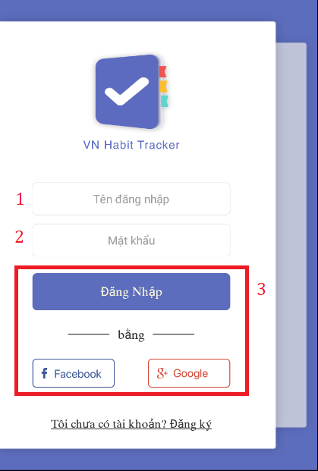

|  |  |
| --- | --- |
| Step | Description |
| 1 | Fill in field: “Tên đăng nhập” |
| 2 | Fill in field: “Mật khẩu” |
| 3 | Click on “Đăng nhập” button or “Facebook” button or “Google” button |

* + 1. Register

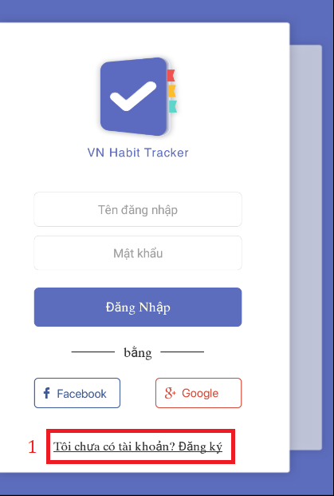

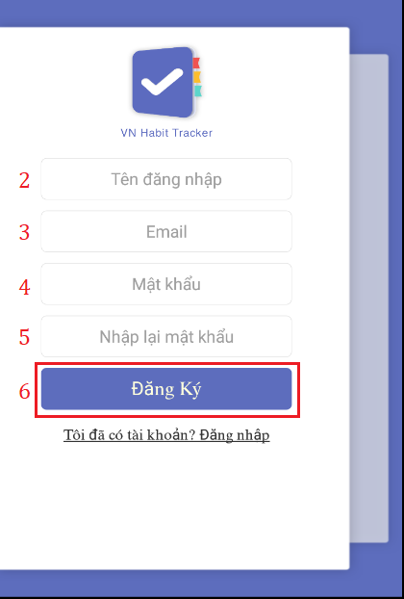

|  |  |
| --- | --- |
| Step | Description |
| 1 | Click on “Tôi chưa có tài khoản?Đăng ký” hyperlinks. |
| 2 | Fill in field: “Tên đăng nhập” |
| 3 | Fill in field: “EMail” |
| 4 | Fill in field: “Mật khẩu” |
| 5 | Fill in field: “Nhập lại mật khẩu” |
| 6 | Click on “Đăng ký” button. |

* + 1. View Main Page

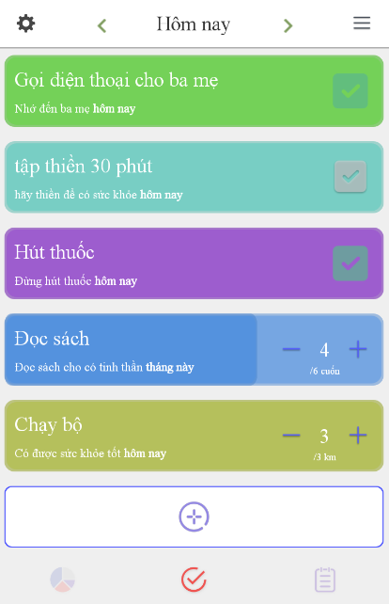

* + 1. Add Habit

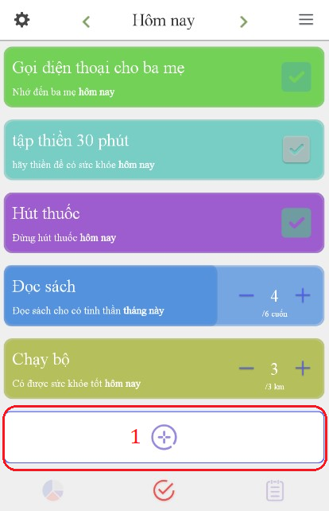

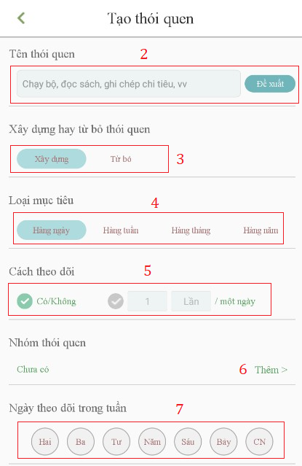

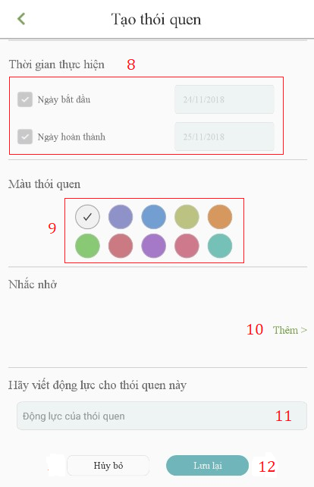

|  |  |
| --- | --- |
| Step | Description |
| 1 | Click on “+” button. |
| 2 | Fill in field: “Tên thói quen” or click on “đề xuất” button. |
| 3 | Click choice “Xây dưng” or “Từ bỏ” button. |
| 4 | Click choice “Hàng ngày” or “Hàng tuần” or “Hàng tháng” or “Hàng năm” button. |
| 5 | Click choice “Có/Không” button or count time. |
| 6 | Click on “Thêm” hyperlink to add group habit. |
| 7 | Select date time to start and finish. |
| 8 | Set start date and finish date. |
| 9 | Click choice color button for habit. |
| 10 | Click on “Thêm” hyperlink to add reminder for habit. |
| 11 | Fill in field:”Động lực”. |
| 12 | Click on “Lưu” button. |

* + 1. Edit Habit

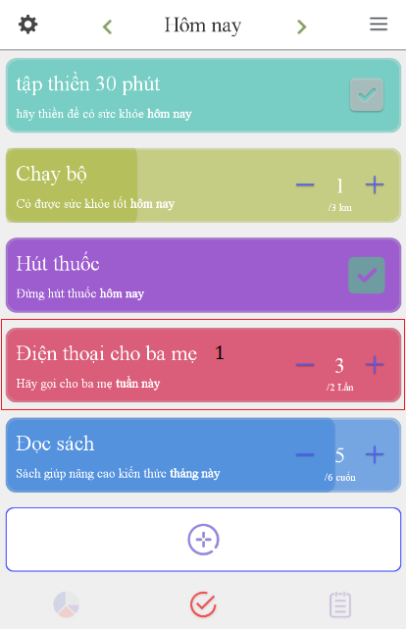

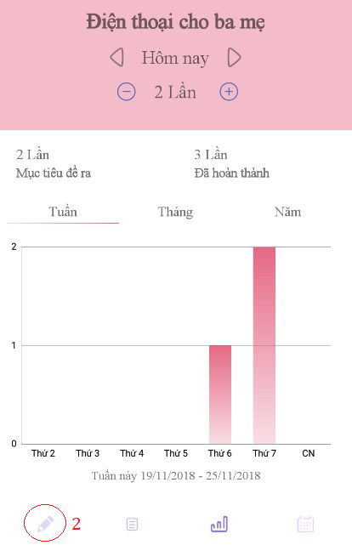

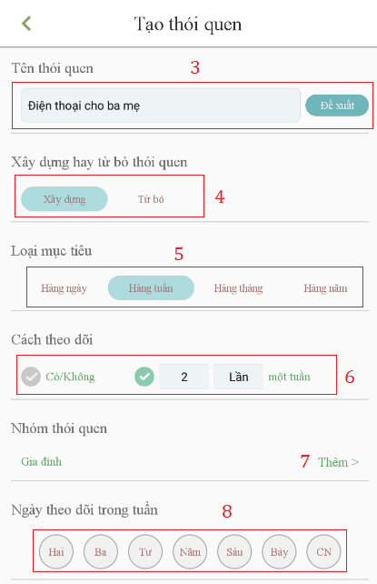

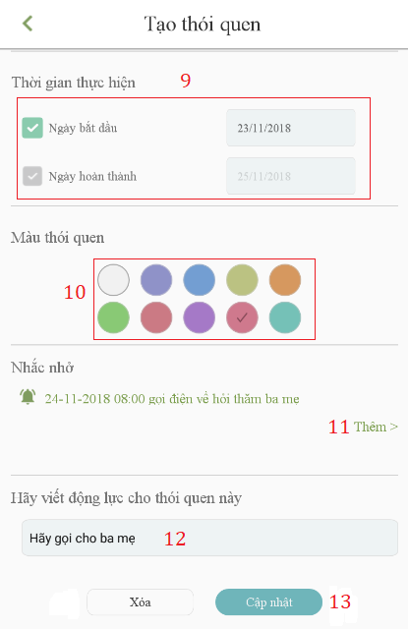

|  |  |
| --- | --- |
| Step | Description |
| 1 | Click into the habit. |
| 2 | Click Edit button. |
| 3 | Fill in field: “Tên thói quen” or click on “đề xuất” button. |
| 4 | Click choice “Xây dưng” or “Từ bỏ” button. |
| 5 | Click choice “Hàng ngày” or “Hàng tuần” or “Hàng tháng” or “Hàng năm” button. |
| 6 | Click choice “Có/Không” button or count time. |
| 7 | Click on “Thêm” hyperlink to add group habit. |
| 8 | Select date time to start and finish. |
| 9 | Set start date and finish date. |
| 10 | Click choice color button for habit. |
| 11 | Click on “Thêm” hyperlink to add reminder for habit. |
| 12 | Fill in field:”Động lực”. |
| 13 | Click on “Cập nhật” button. |

* + 1. Delete Habit

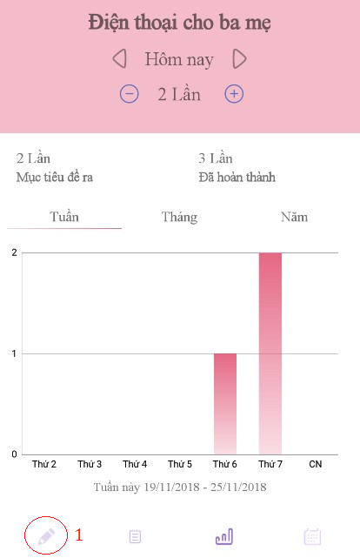

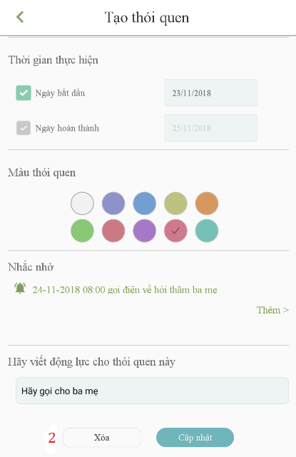

|  |  |
| --- | --- |
| Step | Description |
| 1 | Click Edit button. |
| 2 | Click on “Xóa” button. |

* + 1. View All Statistic of User

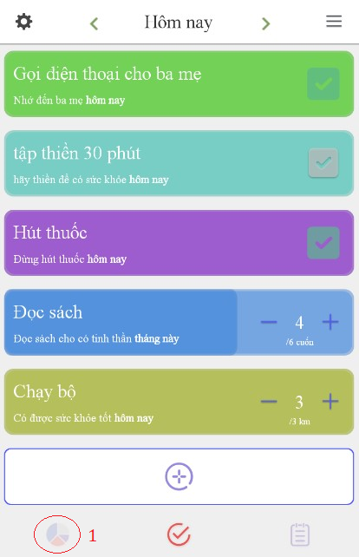

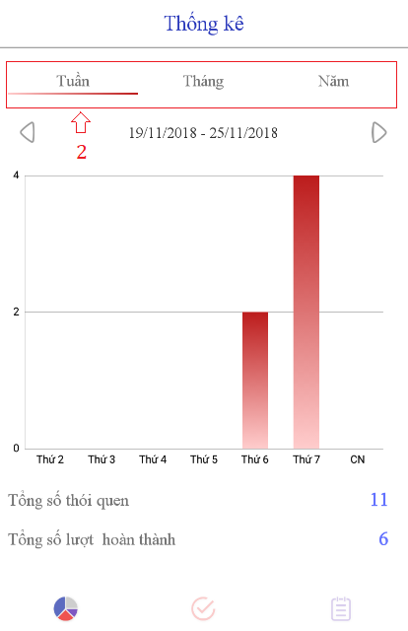

|  |  |
| --- | --- |
| Step | Description |
| 1 | Click on Statistic button. |
| 2 | View statistic follow week, month, year. |

* + 1. Add Reminder

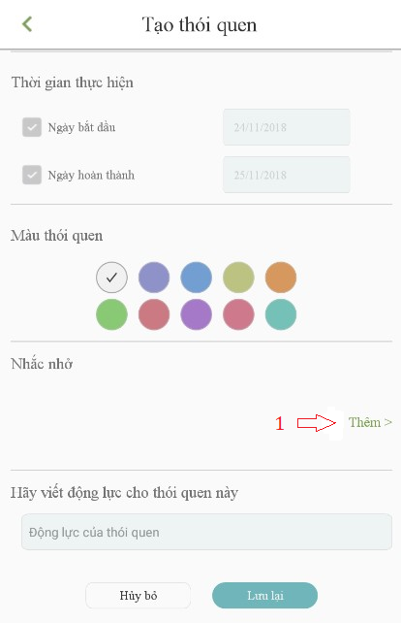

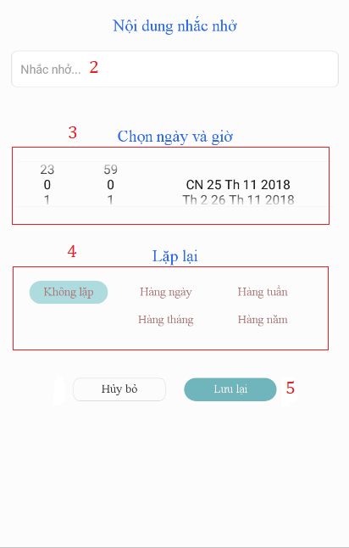

|  |  |
| --- | --- |
| Step | Description |
| 1 | Click on “Thêm” button. |
| 2 | Fill in field: “Tên đăng nhập”. |
| 3 | Set date and time. |
| 4 | Click choice “Hàng ngày” or “Hàng tuần” or “Hàng tháng” or “Hàng năm” button. |
| 5 | Click on “Lưu lại” button. |

* + 1. Delete Reminder

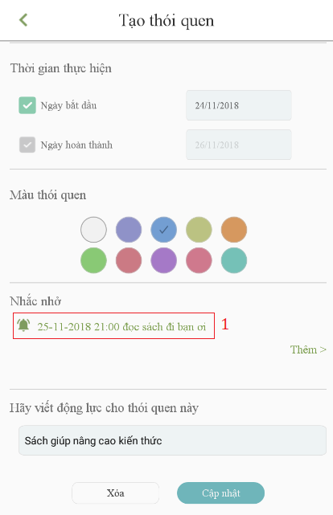

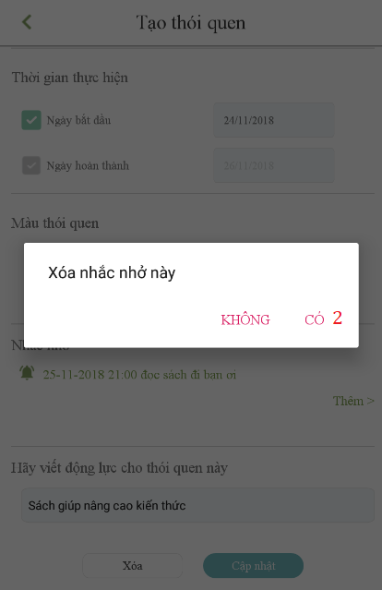

|  |  |
| --- | --- |
| Step | Description |
| 1 | Click on reminder. |
| 2 | Click on “Có” button. |

* + 1. Add Group

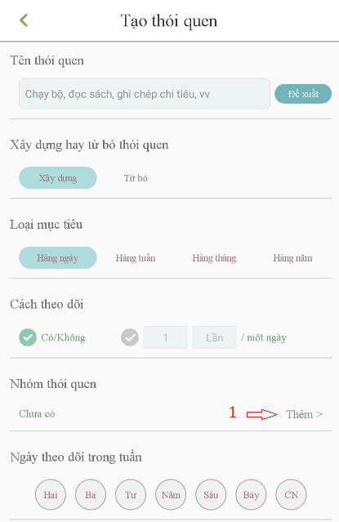

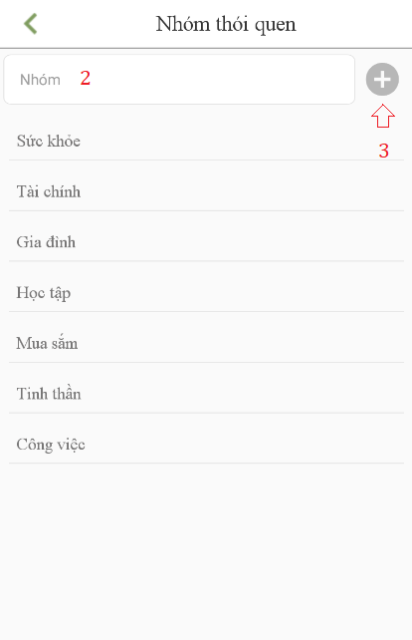

|  |  |
| --- | --- |
| Step | Description |
| 1 | Click on “Thêm” button on “Nhóm thói quen” required field. |
| 2 | Fill in field: “Nhóm”. |
| 3 | Click on “+” button. |

F1. ソフトウェアユーザーマニュアル

1.インストレーションガイド

* + 1. ハードウェア要件

|  |  |
| --- | --- |
| ハードウェア | 記述 |
| インターネット | 8 Mbps以上 |
| プロセッサー | Intel® Core(TM) i5 CPU , M 460 @ 2.53GHz以上 |
| RAM | 4GB以上 |
| ハードディスクドライブ | 40GB 以上 |

* + 1. ソフトウェア要件

|  |  |
| --- | --- |
| ソフトウェア | アプリケーション名前／バージョン |
| オペレーティングシステム | Window 10 Pro-64bit |
| 環境 | VueJS 2.0 |
| DBMS | Microsoft SQL server 2014 v17.4 |
| ソース管理 | Github |
| ウェブブラウザ | Chrome 63 以上 |

2. ユーザーガイド

* + 1. ログイン



|  |  |
| --- | --- |
| ステップ | 説明 |
| 1 | ユーザー名の内容を入力します。 |
| 2 | パスワードの内容を入力します。 |
| 3 | 「Login 」のボタンをクリックします。 |

* + 1. レジスター





|  |  |
| --- | --- |
| ステップ | 説明 |
| 1 | "Tôi chưa có tài khoản？Đăng ký"ハイパーリンクをクリックします。 |
| 2 | 入力フィールド： "Tên đăng nhập" |
| 3 | 入力フィールド： "E-Mail" |
| 4 | 入力フィールド: “Mật khẩu” |
| 5 | 入力フィールド: “Nhập lại mật khẩu” |
| 6 | "Đăng ký" ボタンをクリックしてください。 |

* + 1. メインメニューを表示



* + 1. 習慣を追加する







|  |  |
| --- | --- |
| ステップ | 説明 |
| 1 | 「+」ボタンをクリック。 |
| 2 | フィールドに入力してください：「Tênthóiquen」または「đềxuất」ボタンをクリックしてください。 |
| 3 | 選択 "Xây dưng"または「Từ bỏ」ボタンをクリックします。 |
| 4 | 「hàng ngày」または「hàng tuần」または「hàng tháng」または「hàng năm」ボタンをクリックします。 |
| 5 | クリックして「Có/Không」ボタンをクリックするか、時間を数える。 |
| 6 | グループの習慣を追加するには、「Thêm」ハイパーリンクをクリックしてください。 |
| 7 | 日付を選択してください。 |
| 8 | 開始日と終了日を設定します。 |
| 9 | 選択した別のカラーボタンをクリックします。 |
| 10 | 「Thêm」ハイパーリンクをクリックして、習慣のためのリマインダを追加します。 |
| 11 | フィールドに入力してください：「Động lực」。 |
| 12 | 「Lưu」ボタンをクリック。 |

* + 1. 習慣を編集する









|  |  |
| --- | --- |
| Step | Description |
| 1 | Click into the habit. |
| 2 | Click Edit button. |
| 3 | Fill in field: “Tên thói quen” or click on “đề xuất” button. |
| 4 | Click choice “Xây dưng” or “Từ bỏ” button. |
| 5 | Click choice “Hàng ngày” or “Hàng tuần” or “Hàng tháng” or “Hàng năm” button. |
| 6 | Click choice “Có/Không” button or count time. |
| 7 | Click on “Thêm” hyperlink to add group habit. |
| 8 | Select date time to start and finish. |
| 9 | Set start date and finish date. |
| 10 | Click choice color button for habit. |
| 11 | Click on “Thêm” hyperlink to add reminder for habit. |
| 12 | Fill in field:”Động lực”. |
| 13 | Click on “Cập nhật” button. |

* + 1. 習慣を削除する





|  |  |
| --- | --- |
| Step | Description |
| 1 | Click Edit button. |
| 2 | Click on “Xóa” button. |

* + 1. ユーザーの全統計を表示





|  |  |
| --- | --- |
| Step | Description |
| 1 | Click on Statistic button. |
| 2 | View statistic follow week, month, year. |

* + 1. リマインダを追加する





|  |  |
| --- | --- |
| Step | Description |
| 1 | Click on “Thêm” button. |
| 2 | Fill in field: “Tên đăng nhập”. |
| 3 | Set date and time. |
| 4 | Click choice “Hàng ngày” or “Hàng tuần” or “Hàng tháng” or “Hàng năm” button. |
| 5 | Click on “Lưu lại” button. |

* + 1. リマインダを削除する





|  |  |
| --- | --- |
| Step | Description |
| 1 | Click on reminder. |
| 2 | Click on “Có” button. |

* + 1. グループを追加





|  |  |
| --- | --- |
| Step | Description |
| 1 | Click on “Thêm” button on “Nhóm thói quen” required field. |
| 2 | Fill in field: “Nhóm”. |
| 3 | Click on “+” button. |

1. Appendix
2. Sofware Engineering 9th Edition, By Ian Sommerville
3. StarUML Documentation For Activity Diagram

http://www.uml-diagrams.org/activity-diagrams-controls.html

1. **StarUML Documentation of IBM**

<https://www.ibm.com/developerworks/rational/library/content/RationalEdge/sep03/f_umlbasics_db.pdf>

1. UML For Drawing Diagram (2.0 Standard)

<http://www.omg.org/spec/UML/2.0>

1. Android Studio Documentation

https://developer.android.com/docs/